



**Informatics Institute of Technology**

**Department of Computing**

**Web Design & Development**

**4COSC011 W**

Group Coursework Report

* Author - Udage Kankanamge Lahiru Dilshan
* UoW ID - w1867452
* IIT ID - 20210362
* Tutorial Group - E-2
* Student Role - Student 03 – CS

**Table of Contents**

**Table of Contents ---------------------------------- Page No**

1. Introduction________________________________________ 2
2. Technical Discussion_______________________________ 3

* quiz page.html_______________________________ 3
* about us.html_________________________________ 10

1. Janet______________________________________________ 12
2. References________________________________________ 12
3. Appendices_________________________________________ 13

* Appendix I: Code_____________________________ 13
  + - quiz page.html___________________________ 12
    - about us.html___________________________ 17
    - quiz page.css__________________________ 21
    - about us.css___________________________ 25
    - about us.js_____________________________ 29
* Appendix II: Screenshots____________________ 35
  + - quiz page.html___________________________35
    - about us.html____________________________ 39
* Page Editor_____________________ 41
* Appendix III: Individual Statement____________ 42

1. Thank You_________________________________________ 43

Introduction

* Our Topic,

**Welcome To the Future**

* Student 01 – Chamidu Shilakshitha
* Task – 01 - Presentation Page
* Task – 04 - Buy Prioducts Page
* Student 02 – Navidu Chrishen

* Task – 02 - Main Page
* Task – 03 - Query Form Page
* Task – 9a - External CSS
* Student 03 – Lahiru Dilshan
* Task – 06 - Quiz Page
* Task – 08 - About Page
* Student 04 – Isuru Udula
* Task – 05 - Diagram (SVG)
* Task – 07 - Thumbnails Images
* All students,
* Task – 9b - External CSS
* Task – 10 - Page Editor
* Task – 11 - Logo/Page Editor
* Task – 12 - Anchors
* Task – 13 - Additional Interactivity
* Our web course work was based on "Science". On behalf of that we chose "Crypto currency" as the topic which is most current trends in field of computer science. It’s a very professional web site. We successfully completed the site as a great team.

**Technical Discussion**

**Quiz page.HTML**

1 **let** valueArray1= getRadioValue(myRef.q1);

2

3 **if** (valueArray1=="Dogecoin"){

4 total=total+**2**;

5 **var** mydiv=document.getElementById("q133");

6 mydiv.innerHTML="<span style=\"color:#008000\"><strong>Dogecoin-</strong><i>your answer is correct</i></span>";

7 }

8 **else** **if** (valueArray1=="Ether"){

9 total=total-**1**;

10 **var** mydiv1=document.getElementById("q133");

11 mydiv1.innerHTML="<span style=\"color:#008000\"><strong>Dogecoin-</strong><i>the correct answer</i></span>";

12 **var** mydiv2=document.getElementById("q111");

13 mydiv2.innerHTML="<span style=\"color:#A41623\"><strong>Ether-</strong><i>your answer is incorrect</i></span>";

14 }

15 **else** **if** (valueArray1=="Tether"){

16 total=total-**1**;

17 **var** mydiv1=document.getElementById("q133");

18 mydiv1.innerHTML="<span style=\"color:#008000\"><strong>Dogecoin-</strong><i>the correct answer</i></span>";

19 **var** mydiv2=document.getElementById("q122");

20 mydiv2.innerHTML="<span style=\"color:#A41623\"><strong>Tether-</strong><i>your answer is incorrect</i></span>";

21 }

22 **else** **if** (valueArray1=="Cardano"){

23 total=total-**1**;

24 **var** mydiv1=document.getElementById("q133");

25 mydiv1.innerHTML="<span style=\"color:#008000\"><strong>Dogecoin-</strong><i>the correct answer</i></span>";

26 **var** mydiv2=document.getElementById("q144");

27 mydiv2.innerHTML="<span style=\"color:#A41623\"><strong>Cardano-</strong><i>your answer is incorrect</i></span>";

28 }

29 **else** **if** (valueArray1==""){

30 total=total;

31 **var** mydiv=document.getElementById("q133");

32 mydiv.innerHTML="<span style=\"color:#008000\"><strong>Dogecoin-</strong><i>the correct answer</i></span>";

33

34 }

I used the above JavaScript validation check if the answer is correct. I store the checked value to a variable using **getRadioValue** and if the answer is correct the color of it changes to green color and display “-***your answer is correct*** *“ and* if the answer is incorrect it will change the color of checked answer to red and display-“***your answer is incorrect*** “ and also change the color of the correct answer to green stating “*correct answer*” in front of it.

1 **function** myTimer() {

2 document.getElementById('timer').innerHTML = sec + "sec left";

3 sec--;

4 **if** (sec == -**1**) {

5 clearInterval(time);

6 getTheValues(quiz);

7 document.getElementById('sub').style.display="none";

8 }

9 }

**This is the process where the value of the radio button is taking**

1 **<form** **name=**"quiz"**>**

2 **<ol** **type=**"1"**>**

3 **<li>**Which of these cryptocurrencies is the oldest?**</li>**

4

5 **<input** **type=**"radio" **id=**"q11" **name=**"q1" **value=**"Ether"**>**

6 **<label** **id=**"q111"**>**Ether**</label><br>**

7 **<input** **type=**"radio" **id=**"q12" **name=**"q1" **value=**"Tether"**>**

8 **<label** **id=**"q122"**>**Tether**</label><br>**

9 **<input** **type=**"radio" **id=**"q13 " **name=**"q1" **value=**"Dogecoin"**>**

10 **<label** **id =**"q133"**>**Dogecoin**</label><br>**

11 **<input** **type=**"radio" **id=**"q14" **name=**"q1" **value=**"Cardano"**>**

12 **<label** **id=**"q144"**>**Cardano**</label>**

13

14

15 **<li>**After Bitcoin, Ether and Tether, which are the biggest crypto coins?**</li>**

16

17 **<input** **type=**"radio" **id=**"q21" **name=**"q2" **value=**"Solana"**>**

18 **<label** **id=**"q211"**>**Solana**</label><br>**

19 **<input** **type=**"radio" **id=**"q22" **name=**"q2" **value=**"Binance"**>**

20 **<label** **id=**"q222"**>**Binance coin**</label><br>**

21 **<input** **type=**"radio" **id=**"q23" **name=**"q2" **value=**"Cardano"**>**

22 **<label** **id=**"q233"**>**Cardano**</label><br>**

23 **<input** **type=**"radio" **id=**"q24" **name=**"q2" **value=**"Dogecoin"**>**

24 **<label** **id=**"q244"**>**Dogecoin**</label>**

25

26

27 **<li>**Why is buying Tether an integral step to acquiring Bitcoin in China?**</li>**

28

29 **<input** **type=**"radio" **id=**"q31" **name=**"q3" **value=**"It makes buying bitcoin cheaper"**>**

30 **<label** **id=**"q311"**>**It makes buying bitcoin cheaper **</label><br>**

31 **<input** **type=**"radio" **id=**"q32" **name=**"q3" **value=**"Bitcion exchanges only accept only USD dominated payments"**>**

32 **<label** **id=**"q322"**>**Bitcion exchanges only accept only USD dominated payments**</label><br>**

33 **<input** **type=**"radio" **id=**"q33" **name=**"q3" **value=**"Buying Bitcoins directly in china is banded"**>**

34 **<label** **id=**"q333"**>**Buying Bitcoins directly in china is banded **</label><br>**

35 **<input** **type=**"radio" **id=**"q34" **name=**"q3" **value=**"It allows access to services like Alipay"**>**

36 **<label** **id=**"q344"**>**It allows access to services like Alipay **</label>**

37

38 **<li>**What is a CBDC?**</li>**

39

40 **<input** **type=**"radio" **id=**"q41" **name=**"q4" **value=**"A way encoding tion on a blaockchain"**>**

41 **<label** **id=**"q411"**>**A way encoding tion on a blaockchain **</label><br>**

42 **<input** **type=**"radio" **id=**"q42" **name=**"q4" **value=**"A reward you get for lending bitcoin"**>**

43 **<label** **id=**"q422"**>**A reward you get for lending bitcoin **</label><br>**

44 **<input** **type=**"radio" **id=**"q43" **name=**"q4" **value=**"A protocol used to convert digital currencies to real cash"**>**

45 **<label** **id=**"q433"**>**A protocol used to convert digital currencies to real cash**</label><br>**

46 **<input** **type=**"radio" **id=**"q44" **name=**"q4" **value=**"A digital currency issued by the central bank"**>**

47 **<label** **id=**"q444"**>**A digital currency issued by the central bank**</label>**

48

49 **<li>**What is the world’s most actively traded crypto coin?**</li>**

50

51 **<input** **type=**"radio" **id=**"q51" **name=**"q5" **value=**"Bitcoin"**>**

52 **<label** **id=**"q511"**>**Bitcoin**</label><br>**

53 **<input** **type=**"radio" **id=**"q52" **name=**"q5" **value=**"Ether"**>**

54 **<label** **id=**"q522"**>**Ether **</label><br>**

55 **<input** **type=**"radio" **id=**"q53" **name=**"q5" **value=**"Tether"**>**

56 **<label** **id=**"q533"**>**Tether**</label><br>**

57 **<input** **type=**"radio" **id=**"q54" **name=**"q5" **value=**"Dogecoin"**>**

58 **<label** **id=**"q544"**>**Dogecoin **</label>**

59

60 **<li>**How much energy does Bitcoin consume annually?**</li>**

61

62 **<input** **type=**"radio" **id=**"q61" **name=**"q6" **value=**"More than Greece"**>**

63 **<label** **id=**"q611"**>**More than Greece**</label><br>**

64 **<input** **type=**"radio" **id=**"q62" **name=**"q6" **value=**"More than Australia"**>**

65 **<label** **id=**"q622"**>**More than Australia**</label><br>**

66 **<input** **type=**"radio" **id=**"q63" **name=**"q6" **value=**"More than American Airlines"**>**

67 **<label** **id=**"q633"**>**More than American Airlines **</label><br>**

68 **<input** **type=**"radio" **id=**"q64" **name=**"q6" **value=**"More than U.S federal government"**>**

69 **<label** **id=**"q644"**>**More than U.S federal government **</label>**

70

71 **<li>**What is staking?**</li>**

72

73 **<input** **type=**"radio" **id=**"q71" **name=**"q7" **value=**"Pledging your tokens to verify transactions"**>**

74 **<label** **id=**"q711"**>**Pledging your tokens to verify transactions **</label><br>**

75 **<input** **type=**"radio" **id=**"q72" **name=**"q7" **value=**"Slang for buying cryptocurrency"**>**

76 **<label** **id=**"q722"**>**Slang for buying cryptocurrency**</label><br>**

77 **<input** **type=**"radio" **id=**"q73" **name=**"q7" **value=**"Lending your cryptocurrency to other users"**>**

78 **<label** **id=**"q733"**>**Lending your cryptocurrency to other users**</label>**

79

80

81 **<li>**What is a rug pull?**</li>**

82

83 **<input** **type=**"radio" **id=**"q81" **name=**"q8" **value=**"An alternative cryptocurrency"**>**

84 **<label** **id=**"q811"**>**An alternative cryptocurrency**</label><br>**

85 **<input** **type=**"radio" **id=**"q82" **name=**"q8" **value=**"The crypto equivalent for pump and dump"**>**

86 **<label** **id=**"q822"**>**The crypto equivalent for pump and dump **</label><br>**

87 **<input** **type=**"radio" **id=**"q83" **name=**"q8" **value=**"Slang for teasing someone about their crypto Purchases"**>**

88 **<label** **id=**"q833"**>**Slang for teasing someone about their crypto Purchases **</label><br>**

89 **<input** **type=**"radio" **id=**"q84" **name=**"q8" **value=**"An upgrade to a cryptocurrency"**>**

90 **<label** **id=**"q844"**>**An upgrade to a cryptocurrency **</label>**

91

92 **<li>**Why is Cardano often described as a green coin?**</li>**

93

94 **<input** **type=**"radio" **id=**"q91" **name=**"q9" **value=**"It mandates that renewable power must be used for coin mining"**>**

95 **<label** **id=**"q911"**>**It mandates that renewable power must be used for coin mining **</label><br>**

96 **<input** **type=**"radio" **id=**"q92" **name=**"q9" **value=**"It’s less popular and smaller than bitcoin, so it simply uses less energy"**>**

97 **<label** **id=**"q922"**>**It’s less popular and smaller than bitcoin, so it simply uses less energy**</label><br>**

98 **<input** **type=**"radio" **id=**"q93" **name=**"q9" **value=**"The method for verifying transactions is different and less energy intensive than for"**>**

99 **<label** **id=**"q933"**>**The method for verifying transactions is different and less energy intensive than for**<br>**bitcoin **</label><br>**

100 **<input** **type=**"radio" **id=**"q94" **name=**"q9" **value=**"Its logo on currency exchanges is green"**>**

101 **<label** **id=**"q944"**>**Its logo on currency exchanges is green**</label>**

102

103 **<li>**What is a Binance Coin burn?**</li>**

104

105 **<input** **type=**"radio" **id=**"q101" **name=**"q10" **value=**"The organized destruction of coins"**>**

106 **<label** **id=**"q1011"**>**The organized destruction of coins**</label><br>**

107 **<input** **type=**"radio" **id=**"q102" **name=**"q10" **value=**"When prices soar more than 10% in a day"**>**

108 **<label** **id=**"q1022"**>**When prices soar more than 10% in a day**</label><br>**

109 **<input** **type=**"radio" **id=**"q103" **name=**"q10" **value=**"A giveaway of coins for promotional purposes"**>**

110 **<label** **id=**"q1033"**>**A giveaway of coins for promotional purposes**</label><br>**

111 **<input** **type=**"radio" **id=**"q104" **name=**"q10" **value=**"A police sting designed to trap criminals using the coin"**>**

112 **<label** **id=**"q1044"**>**A police sting designed to trap criminals using the coin**</label>**

113

114

115 **</ol>**

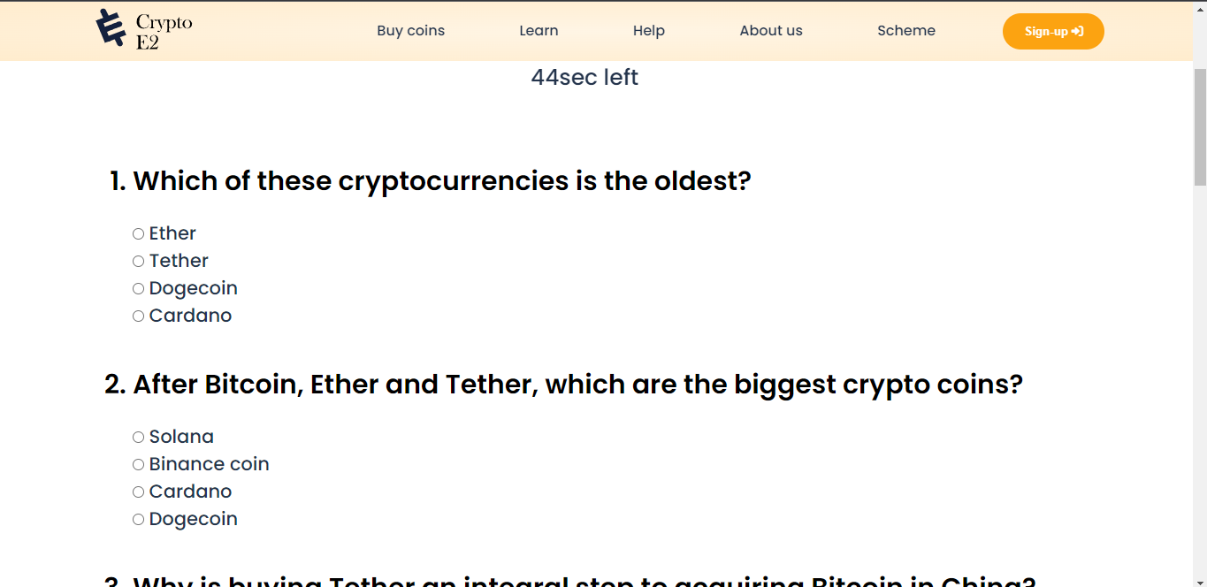The above HTML code shows how I code the questions and answers with ***radio buttons***. I wanted to make the quiz ***scrollable*** because it easy to user to jump to previous questions and change the answers of them.

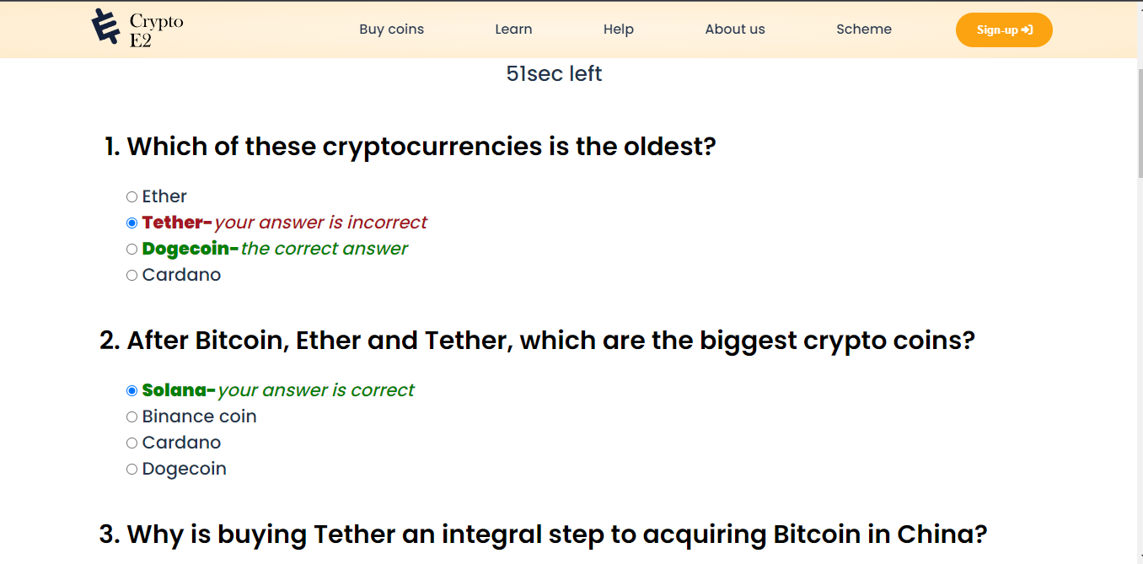**This is how the answers display in the screen when the code runs**

As described, when the user enters the wrong answer and the correct answer the above changes occur in the relative elements. So when the user submit his/her answers or when the time limit exceed the above changes will appear so the user can identify the mistakes and the correct answers after the submission.

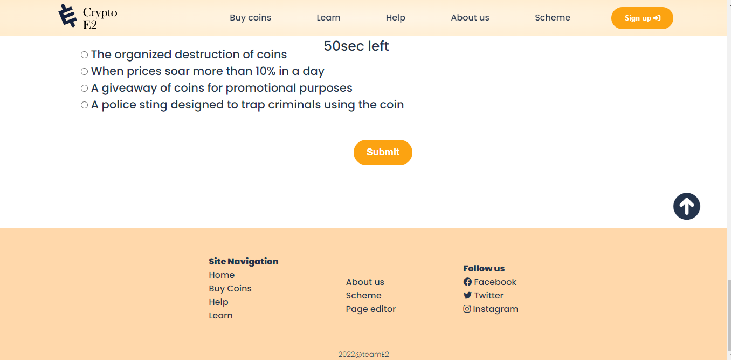

1 **<div** **class=**"submit-btn"**>**

2 **<center>**

3 **<input** **id=**"sub" **type=**"button" **value=**"Submit" **onclick=**"getTheValues(this.form)"**>**

4 **</center>**

**This is the code of the submit button that finalize the quiz and provide the answers to the user.**

1 **<div** **id=**"currentTime" **class=**"timer" **style=**"color: white;" **class=**"d-flex justify-content-end time"**>**

This is the space of the timer in the HTML Page. Since I was making a scrollable quiz in wanted put the timer in the top of the page and make it sticky using CSS.

1 **var** sec = **60**;

2 **var** time = setInterval(myTimer, **1000**);

3

4 **function** myTimer() {

5 document.getElementById('timer').innerHTML = sec + "sec left";

6 sec--;

7 **if** (sec == -**1**) {

8 clearInterval(time);

9 getTheValues(quiz);

10 document.getElementById('sub').style.display="none";

11 }

12 }

This the function that I created to make a timer in the web page. The timer counts 60 seconds

1 **function** getTheValues(myRef){

When the user click on the submit button or when timer run out the above main function will execute.

For every correct answer, every wrong answer, and null response a score will be calculated.

Correct answers= 2marks, wrong answer=-1 and null answers(no radio button was clicked)=0

So according to the final total, the page will change. That was coded as below;

1 **if** (total>=**12** && total<=**20**){

2 document.querySelector("body").style.backgroundColor="#40F99B";}

3 **if**(total>=**8** && total<**12**){

4 document.querySelector("body").style.backgroundColor="#F0F757";}

5 **if**(total<**5**){

6 document.querySelector("body").style.backgroundColor="#FF4949";}

When the user clicks the submit button before the timer run out the timer will stop so the user can see how much time was taken to the completion.

1 clearInterval(time);

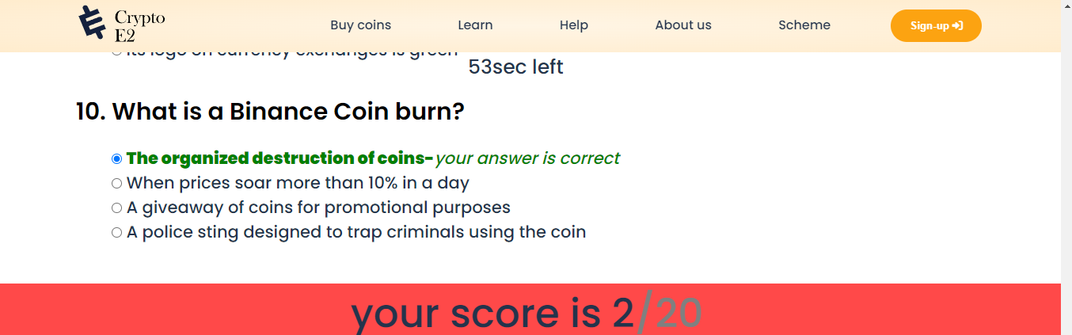clearInterval function is called inside the main getValue function which is executes when only the user clicks the submit button so the timer will stop when user clicks the submit button.

This is how the timer was stopped by the submission.

When user clicks on the submit button the button will disappear and a new retake **quiz button** will appear.

1 **<center><button** **id=**"retake" **style=**"display: none;"**><a** **href=**""**>**Retake quiz**</a></button></center>**

1 document.getElementById("retake").style.display="block";

1 document.getElementById("sub").style.display="none";

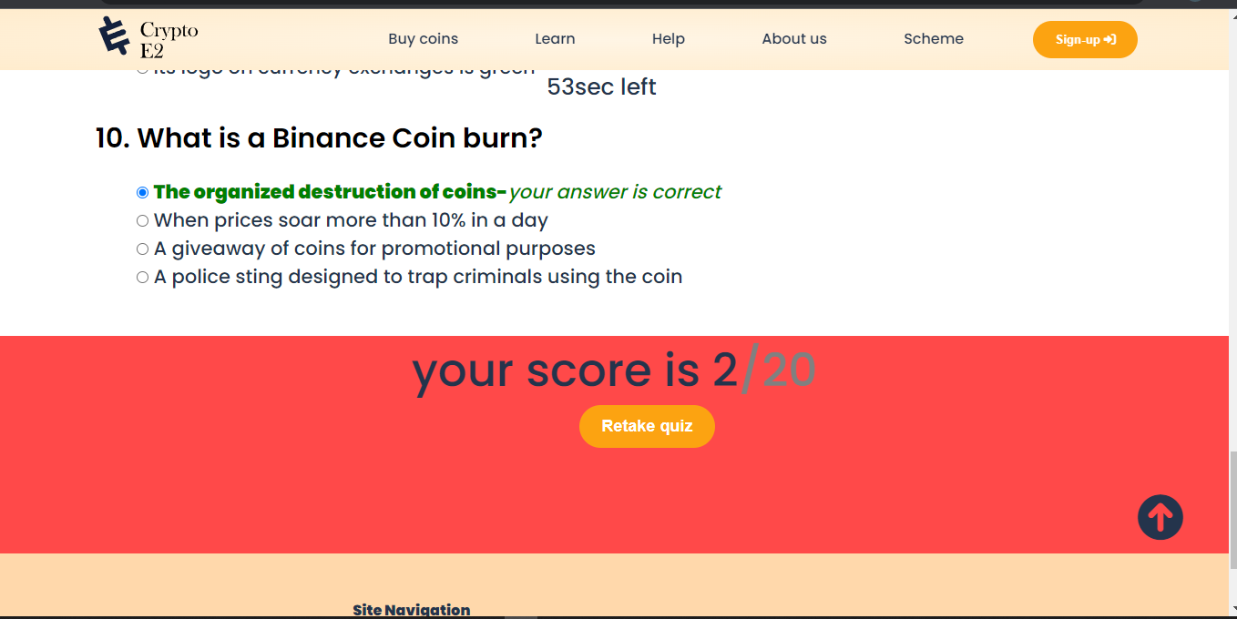This how the appearance occurs. These functions are inside the main function **getTheValues** so click on the submit button will causes these events.

The link to the quiz page is in the quiz home page.

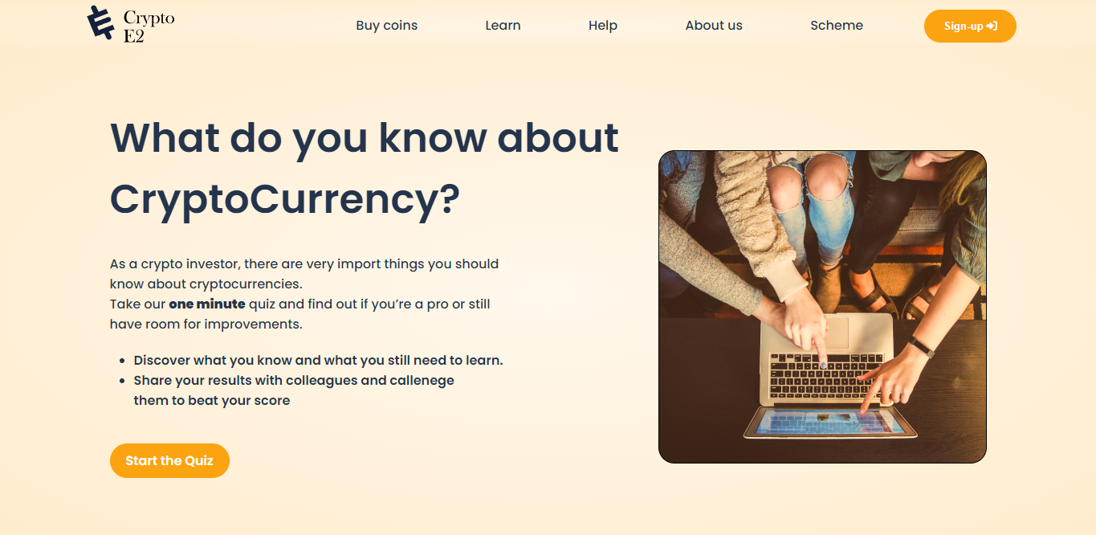The link on the start the quiz button opens door to the quiz page. The moment that quiz page is loaded the quiz timer will start.

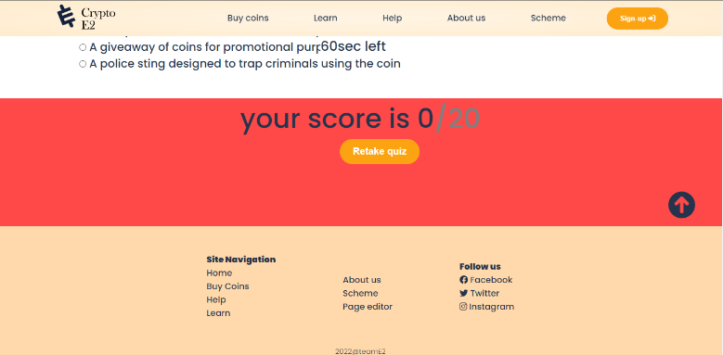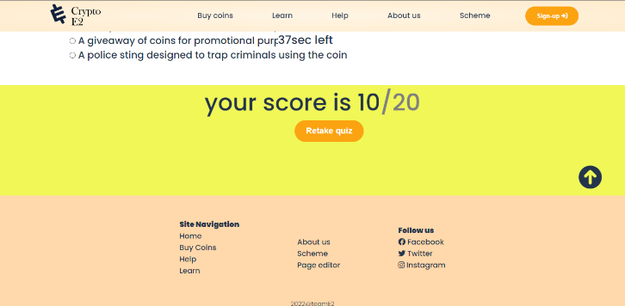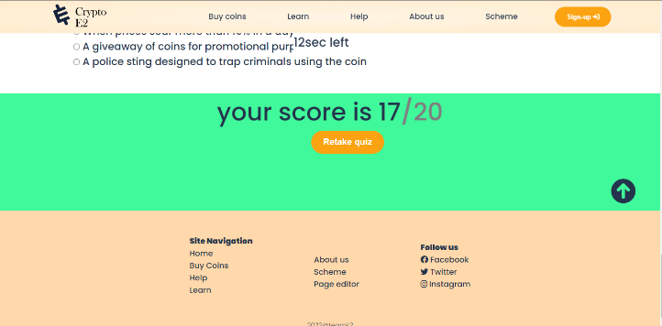

The above images show how the background color changes according to the total marks of the quiz.

**about us.HTML**

1 *<!-- image contianer class -->*

2 **<div** **class=**"imageContainer"**>**

3 **<div** **class=**"image"**>**

4 **<img** **class=**"image_img" **src=**"chamidu 2.jpg"**>**

5 **<div** **class=**"image_overlay image_overlay_blur"**>**

6 **<div** **class=**"image_title"**><h1>**Student 1**</h1></div>**

7 **<p** **class=**"image_description"**>**

8 student ID:20210289**<br>**

9 Chamidu Shilakshitha**<br>**

10 **</p>**

11 **</div>**

12 **</div>**

* This is how I code the about us using <p> tags and <div> tags in html.
* I used 4 columns and one line to illustrate the student pictures.
* Ex: This is the description of the 1st student.

1 .image_overlay{

2 **position**: **absolute**;

3 **top**: **0**;

4 **left**: **0**;

5 **width**: **100**%;

6 **height**: **100**%;

7 **background**: rgba(**0**, **0**, **0**, **0**.**6**);

8 **color**: white;

9 **display**: flex;

10 flex-**direction**: column;

11 align-items: **center**;

12 **justify**-**content**:**center** ;

13 **opacity**: **0**;

14 transition: **opacity** **0.55s**;

15 }

16 .image_overlay_blur{

17 backdrop-filter: blur(**5px**);

18 }

19 .image_overlay:hover{

20 **opacity**: **1**;

21 }

22 .image_overlay > *{

23 transform: translateY(**30px**);

24 transition: transform **0.55s**;

25 }

26 .image_overlay:hover > *{

27 transform: translateY(**0**);

28 }

This how I used the CSS to display the text behind the image when the mouse take over on it.

The image colors will blur and the student details will appear on the image.

**This is how the Mouse over effect works.**

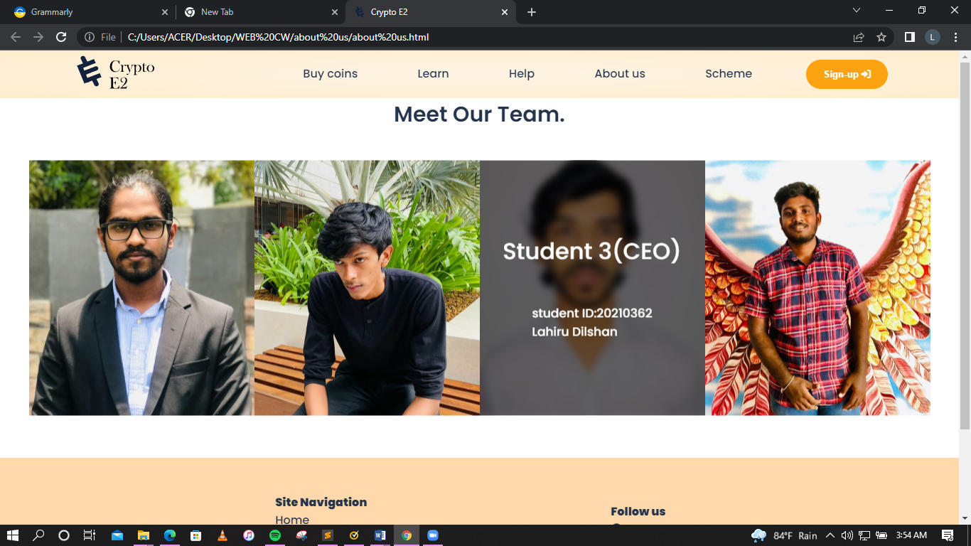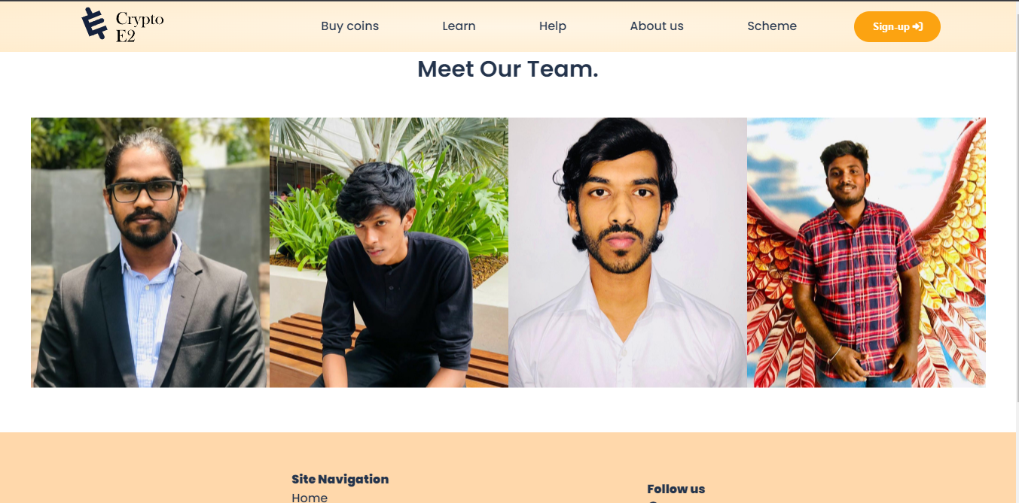

**Janet**

* This crypto currency website was built using Janet rules and restrictions. Janet was created to protect Janet users from the transmission of false or invasive information, and it is essential to follow a research project that has been correctly implemented. In these instances, the organization must seek Janet's approval before beginning the operation and comprehend the responsibility for legal hurdles in order to assure compliance.
* Janet will not be used for the following purposes:
* Copyright infringement.
* To transmit or create unfriendly material.
* This “Crypto E2” web page was developed by me and my group members as a team to further improve.

**References**

[**https://www.w3schools.com/**](https://www.w3schools.com/)

[**https://stackoverflow.com**](https://stackoverflow.com)

**Appendices**

**Appendix I: Code**

**quiz page.html**

1 ***<!DOCTYPE html>***

2 **<html** **lang=**"en"**>**

3 **<head>**

4 **<link** **rel=**"icon" **href=**"Group2.png"**>**

5 **<meta** **charset=**"UTF-8"**>**

6 **<meta** **http-equiv=**"X-UA-Compatible" **content=**"IE=edge"**>**

7 **<meta** **name=**"viewport" **content=**"width=device-width, initial-scale=1.0"**>**

8 **<title>**Crypto E2**</title>**

9 **<link** **rel=**"stylesheet" **href=**"quiz.css"**>**

10 **<link** **rel=**"preconnect" **href=**"https://fonts.googleapis.com"**>**

11 **<link** **rel=**"preconnect" **href=**"https://fonts.gstatic.com" **crossorigin>**

12 **<link** **href=**"https://fonts.googleapis.com/css2?family=Oswald:wght@500&family=Poppins:wght@100;300;500;600;900&display=swap" **rel=**"stylesheet"**>**

13 **<script src=**"https://kit.fontawesome.com/1ee22184a8.js" **crossorigin=**"anonymous"**></script>**

14 **<script src=**"quize page.js"**>**

15

16 **</script>**

17 **</head>**

18 **<body>**

19 **<div** **class=**"nav-bar"**>**

20 **<div** **class=**"logo"**>**

21 **<a** **href=**""**><img** **src=**"logo.svg" **alt=**"Home"**></a>**

22 **</div>**

23 **<div** **class=**"nav-list"**>**

24 **<ul>**

25 **<li><a** **href=**"#"**>**Buy coins**</a></li>**

26 **<li><a** **href=**"#"**>**Learn**</a></li>**

27 **<li><a** **href=**"#"**>**Help**</a></li>**

28 **<li><a** **href=**"#"**>**About us**</a></li>**

29 **<li><a** **href=**"#"**>**Scheme**</a></li>**

30 **<button** **class=**"nav-btn"**>**Sign-up **<span><i** **class=**"fa-solid fa-right-to-bracket"**></i></span></button>**

31 **</ul>**

32 **</div>**

33 **</div>**

34 **<div** **id=**"quizContainer"**>**

35 **<div** **id=**"currentTime" **class=**"timer" **style=**"color: white;" **class=**"d-flex justify-content-end time"**>**

36 **</div>**

37 **</div>**

38 **<center><p** **id=**"timer"**>**Time : **<span** **id=**"timer"**></span></p></center>**

39 **<div** **class=**"questions"**>**

40 **<div** **class=**"heading"**>**

41 **<h1>**Think You Know Your**<br>** Bitcoin From Dogecoin? **<br>**Test Your Crypto Knowledge**</h1>**

42 **<hr>**

43 **</div>**

44 *<!-- quiz questions -->*

45 **<form** **name=**"quiz"**>**

46 **<ol** **type=**"1"**>**

47 **<li>**Which of these cryptocurrencies is the oldest?**</li>**

48

49 **<input** **type=**"radio" **id=**"q11" **name=**"q1" **value=**"Ether"**>**

50 **<label** **id=**"q111"**>**Ether**</label><br>**

51 **<input** **type=**"radio" **id=**"q12" **name=**"q1" **value=**"Tether"**>**

52 **<label** **id=**"q122"**>**Tether**</label><br>**

53 **<input** **type=**"radio" **id=**"q13 " **name=**"q1" **value=**"Dogecoin"**>**

54 **<label** **id =**"q133"**>**Dogecoin**</label><br>**

55 **<input** **type=**"radio" **id=**"q14" **name=**"q1" **value=**"Cardano"**>**

56 **<label** **id=**"q144"**>**Cardano**</label>**

57

58

59 **<li>**After Bitcoin, Ether and Tether, which are the biggest crypto coins?**</li>**

60

61 **<input** **type=**"radio" **id=**"q21" **name=**"q2" **value=**"Solana"**>**

62 **<label** **id=**"q211"**>**Solana**</label><br>**

63 **<input** **type=**"radio" **id=**"q22" **name=**"q2" **value=**"Binance"**>**

64 **<label** **id=**"q222"**>**Binance coin**</label><br>**

65 **<input** **type=**"radio" **id=**"q23" **name=**"q2" **value=**"Cardano"**>**

66 **<label** **id=**"q233"**>**Cardano**</label><br>**

67 **<input** **type=**"radio" **id=**"q24" **name=**"q2" **value=**"Dogecoin"**>**

68 **<label** **id=**"q244"**>**Dogecoin**</label>**

69

70

71 **<li>**Why is buying Tether an integral step to acquiring Bitcoin in China?**</li>**

72

73 **<input** **type=**"radio" **id=**"q31" **name=**"q3" **value=**"It makes buying bitcoin cheaper"**>**

74 **<label** **id=**"q311"**>**It makes buying bitcoin cheaper **</label><br>**

75 **<input** **type=**"radio" **id=**"q32" **name=**"q3" **value=**"Bitcion exchanges only accept only USD dominated payments"**>**

76 **<label** **id=**"q322"**>**Bitcion exchanges only accept only USD dominated payments**</label><br>**

77 **<input** **type=**"radio" **id=**"q33" **name=**"q3" **value=**"Buying Bitcoins directly in china is banded"**>**

78 **<label** **id=**"q333"**>**Buying Bitcoins directly in china is banded **</label><br>**

79 **<input** **type=**"radio" **id=**"q34" **name=**"q3" **value=**"It allows access to services like Alipay"**>**

80 **<label** **id=**"q344"**>**It allows access to services like Alipay **</label>**

81

82 **<li>**What is a CBDC?**</li>**

83

84 **<input** **type=**"radio" **id=**"q41" **name=**"q4" **value=**"A way encoding tion on a blaockchain"**>**

85 **<label** **id=**"q411"**>**A way encoding tion on a blaockchain **</label><br>**

86 **<input** **type=**"radio" **id=**"q42" **name=**"q4" **value=**"A reward you get for lending bitcoin"**>**

87 **<label** **id=**"q422"**>**A reward you get for lending bitcoin **</label><br>**

88 **<input** **type=**"radio" **id=**"q43" **name=**"q4" **value=**"A protocol used to convert digital currencies to real cash"**>**

89 **<label** **id=**"q433"**>**A protocol used to convert digital currencies to real cash**</label><br>**

90 **<input** **type=**"radio" **id=**"q44" **name=**"q4" **value=**"A digital currency issued by the central bank"**>**

91 **<label** **id=**"q444"**>**A digital currency issued by the central bank**</label>**

92

93 **<li>**What is the world’s most actively traded crypto coin?**</li>**

94

95 **<input** **type=**"radio" **id=**"q51" **name=**"q5" **value=**"Bitcoin"**>**

96 **<label** **id=**"q511"**>**Bitcoin**</label><br>**

97 **<input** **type=**"radio" **id=**"q52" **name=**"q5" **value=**"Ether"**>**

98 **<label** **id=**"q522"**>**Ether **</label><br>**

99 **<input** **type=**"radio" **id=**"q53" **name=**"q5" **value=**"Tether"**>**

100 **<label** **id=**"q533"**>**Tether**</label><br>**

101 **<input** **type=**"radio" **id=**"q54" **name=**"q5" **value=**"Dogecoin"**>**

102 **<label** **id=**"q544"**>**Dogecoin **</label>**

103

104 **<li>**How much energy does Bitcoin consume annually?**</li>**

105

106 **<input** **type=**"radio" **id=**"q61" **name=**"q6" **value=**"More than Greece"**>**

107 **<label** **id=**"q611"**>**More than Greece**</label><br>**

108 **<input** **type=**"radio" **id=**"q62" **name=**"q6" **value=**"More than Australia"**>**

109 **<label** **id=**"q622"**>**More than Australia**</label><br>**

110 **<input** **type=**"radio" **id=**"q63" **name=**"q6" **value=**"More than American Airlines"**>**

111 **<label** **id=**"q633"**>**More than American Airlines **</label><br>**

112 **<input** **type=**"radio" **id=**"q64" **name=**"q6" **value=**"More than U.S federal government"**>**

113 **<label** **id=**"q644"**>**More than U.S federal government **</label>**

114

115 **<li>**What is staking?**</li>**

116

117 **<input** **type=**"radio" **id=**"q71" **name=**"q7" **value=**"Pledging your tokens to verify transactions"**>**

118 **<label** **id=**"q711"**>**Pledging your tokens to verify transactions **</label><br>**

119 **<input** **type=**"radio" **id=**"q72" **name=**"q7" **value=**"Slang for buying cryptocurrency"**>**

120 **<label** **id=**"q722"**>**Slang for buying cryptocurrency**</label><br>**

121 **<input** **type=**"radio" **id=**"q73" **name=**"q7" **value=**"Lending your cryptocurrency to other users"**>**

122 **<label** **id=**"q733"**>**Lending your cryptocurrency to other users**</label>**

123

124

125 **<li>**What is a rug pull?**</li>**

126

127 **<input** **type=**"radio" **id=**"q81" **name=**"q8" **value=**"An alternative cryptocurrency"**>**

128 **<label** **id=**"q811"**>**An alternative cryptocurrency**</label><br>**

129 **<input** **type=**"radio" **id=**"q82" **name=**"q8" **value=**"The crypto equivalent for pump and dump"**>**

130 **<label** **id=**"q822"**>**The crypto equivalent for pump and dump **</label><br>**

131 **<input** **type=**"radio" **id=**"q83" **name=**"q8" **value=**"Slang for teasing someone about their crypto Purchases"**>**

132 **<label** **id=**"q833"**>**Slang for teasing someone about their crypto Purchases **</label><br>**

133 **<input** **type=**"radio" **id=**"q84" **name=**"q8" **value=**"An upgrade to a cryptocurrency"**>**

134 **<label** **id=**"q844"**>**An upgrade to a cryptocurrency **</label>**

135

136 **<li>**Why is Cardano often described as a green coin?**</li>**

137

138 **<input** **type=**"radio" **id=**"q91" **name=**"q9" **value=**"It mandates that renewable power must be used for coin mining"**>**

139 **<label** **id=**"q911"**>**It mandates that renewable power must be used for coin mining **</label><br>**

140 **<input** **type=**"radio" **id=**"q92" **name=**"q9" **value=**"It’s less popular and smaller than bitcoin, so it simply uses less energy"**>**

141 **<label** **id=**"q922"**>**It’s less popular and smaller than bitcoin, so it simply uses less energy**</label><br>**

142 **<input** **type=**"radio" **id=**"q93" **name=**"q9" **value=**"The method for verifying transactions is different and less energy intensive than for"**>**

143 **<label** **id=**"q933"**>**The method for verifying transactions is different and less energy intensive than for**<br>**bitcoin **</label><br>**

144 **<input** **type=**"radio" **id=**"q94" **name=**"q9" **value=**"Its logo on currency exchanges is green"**>**

145 **<label** **id=**"q944"**>**Its logo on currency exchanges is green**</label>**

146

147 **<li>**What is a Binance Coin burn?**</li>**

148

149 **<input** **type=**"radio" **id=**"q101" **name=**"q10" **value=**"The organized destruction of coins"**>**

150 **<label** **id=**"q1011"**>**The organized destruction of coins**</label><br>**

151 **<input** **type=**"radio" **id=**"q102" **name=**"q10" **value=**"When prices soar more than 10% in a day"**>**

152 **<label** **id=**"q1022"**>**When prices soar more than 10% in a day**</label><br>**

153 **<input** **type=**"radio" **id=**"q103" **name=**"q10" **value=**"A giveaway of coins for promotional purposes"**>**

154 **<label** **id=**"q1033"**>**A giveaway of coins for promotional purposes**</label><br>**

155 **<input** **type=**"radio" **id=**"q104" **name=**"q10" **value=**"A police sting designed to trap criminals using the coin"**>**

156 **<label** **id=**"q1044"**>**A police sting designed to trap criminals using the coin**</label>**

157

158

159 **</ol>**

160 **</div>**

161 *<!-- submit button -->*

162 **<div** **class=**"submit-btn"**>**

163 **<center>**

164 **<input** **id=**"sub" **type=**"button" **value=**"Submit" **onclick=**"getTheValues(this.form)"**>**

165 **</center>**

166 **</div>**

167 **<div** **id=**"scoreMain"**><p** **id=**"score"**></p></div>**

168 **<center><button** **id=**"retake" **style=**"display: none;"**><a** **href=**""**>**Retake quiz**</a></button></center>**

169 **</form>**

170 **<div** **class=**"top"**>**

171 **<h1><a** **href=**"#top"**><i** **class=**"fa-solid fa-circle-arrow-up"**></i></a></i></h1>**

172 **</div>**

173 *<!--footer of the page-->*

174 **<div** **class=**"footer"**>**

175 **<div** **class=**"links"**>**

176 **<div** **class=**"col1"**>**

177 **<ul>**

178 **<li><h4>**Site Navigation**</h4></li>**

179 **<li><a** **href=**"#"**>**Home**</a></li>**

180 **<li><a** **href=**"#"**>**Buy Coins**</a></li>**

181 **<li><a** **href=**"#"**>**Help**</a></li>**

182 **<li><a** **href=**"#"**>**Learn**</a></li>**

183 **</ul>**

184 **</div>**

185 **<div** **class=**"col1"**>**

186 **<ul>**

187 **<li><i** **class=**"fa-solid fa-horizontal-rule"**></i></li>**

188 **<li><a** **href=**"#"**>**About us**</a></li>**

189 **<li><a** **href=**"#"**>**Scheme**</a></li>**

190 **<li><a** **href=**"navindu.html"**>**Page editor**</a></li>**

191 **</ul>**

192 **</div>**

193 **<div** **class=**"col1"**>**

194 **<ul>**

195 **<li><h4>**Follow us**</h4></li>**

196 **<li><i** **class=**"fa-brands fa-facebook"**></i>** **<a** **href=**"https://www.facebook.com/"**>**Facebook**</a></li>**

25 **<li><i** **class=**"fa-brands fa-twitter"**></i>** **<a** **href=**"https://twitter.com/?lang=en"**>**Twitter**</a></li>**

26 **<li><i** **class=**"fa-brands fa-instagram"**></i>** **<a** **href=**"https://www.instagram.com/?hl=en"**>**Instagram**</a></li>**

27 **</ul>**

28 **</div>**

29 **</div>**

30 **<div** **class=**"copyright"**>**

31 **<center>**

32 **<h5>**2022@teamE2**</h5>**

33 **</center>**

34 **</div>**

35 **</div>**

36

37 **</body>**

38 **</html>**

**about us.html**

1 ***<!DOCTYPE html>***

2 **<html** **lang=**"en"**>**

3 **<head>**

4 **<link** **rel=**"icon" **href=**"Group2.png"**>**

5 **<meta** **charset=**"UTF-8"**>**

6 **<meta** **http-equiv=**"X-UA-Compatible" **content=**"IE=edge"**>**

7 **<meta** **name=**"viewport" **content=**"width=device-width, initial-scale=1.0"**>**

8 **<title>**Crypto E2**</title>**

9 **<link** **rel=**"stylesheet" **href=**"about us.css"**>**

10 **<link** **rel=**"preconnect" **href=**"https://fonts.googleapis.com"**>**

11 **<link** **rel=**"preconnect" **href=**"https://fonts.gstatic.com" **crossorigin>**

12 **<link** **href=**"https://fonts.googleapis.com/css2?family=Oswald:wght@500&family=Poppins:wght@100;300;500;600;900&display=swap" **rel=**"stylesheet"**>**

13 **<script src=**"https://kit.fontawesome.com/1ee22184a8.js" **crossorigin=**"anonymous"**></script>**

14 **</head>**

15 **<body>**

16 *<!-- navigation bar -->*

17 **<div** **class=**"nav-bar"**>**

18 **<div** **class=**"logo"**>**

19 **<a** **href=**""**><img** **src=**"logo.svg" **alt=**"Home"**></a>**

20 **</div>**

21 **<div** **class=**"nav-list"**>**

22 **<ul>**

23 **<li><a** **href=**"#"**>**Buy coins**</a></li>**

24 **<li><a** **href=**"/Quiz/quiz home"**>**Learn**</a></li>**

25 **<li><a** **href=**"#"**>**Help**</a></li>**

26 **<li><a** **href=**"#"**>**About us**</a></li>**

27 **<li><a** **href=**"#"**>**Scheme**</a></li>**

28 **<button** **class=**"nav-btn"**>**Sign-up **<span><i** **class=**"fa-solid fa-right-to-bracket"**></i></span></button>**

29 **</ul>**

30 **</div>**

31 **</div>**

32 **<center><h1** **id=**"heading"**>**Meet Our Team.**</h1></center>**

33 *<!-- image contianer class -->*

34 **<div** **class=**"imageContainer"**>**

35 **<div** **class=**"image"**>**

36 **<img** **class=**"image_img" **src=**"chamidu 2.jpg"**>**

37 **<div** **class=**"image_overlay image_overlay_blur"**>**

38 **<div** **class=**"image_title"**><h1>**Student 1**</h1></div>**

39 **<p** **class=**"image_description"**>**

40 student ID:20210289**<br>**

41 Chamidu Shilakshitha**<br>**

42 **</p>**

43 **</div>**

44 **</div>**

45 **<div** **class=**"image"**>**

46 **<img** **class=**"image_img" **src=**"navidu 2.jpg"**>**

47 **<div** **class=**"image_overlay image_overlay_blur"**>**

48 **<div** **class=**"image_title"**><h1>**Student 2**</h1></div>**

49 **<p** **class=**"image_description"**>**

50 student ID:20200935**<br>**

51 Navidu Chrishen**<br>**

52 **</p>**

53 **</div>**

54 **</div>**

55 **<div** **class=**"image"**>**

56 **<img** **class=**"image_img" **src=**"lahiru 1.jpg"**>**

57 **<div** **class=**"image_overlay image_overlay_blur"**>**

58 **<div** **class=**"image_title"**><h1>**Student 3(CEO)**</h1></div>**

59 **<p** **class=**"image_description"**>**

60 student ID:20210362**<br>**

61 Lahiru Dilshan**<br>**

62 **</p>**

63 **</div>**

64 **</div>**

65 **<div** **class=**"image"**>**

66 **<img** **class=**"image_img" **src=**"isuru 2.jpg"**>**

67 **<div** **class=**"image_overlay image_overlay_blur"**>**

68 **<div** **class=**"image_title"**><h1>**Student 4**</h1></div>**

69 **<p** **class=**"image_description"**>**

70 student ID:20210291**<br>**

71 Isuru Udula**<br>**

72 **</p>**

73 **</div>**

74 **</div>**

75 **</div>**

76 *<!--footer of the page-->*

77 **<div** **class=**"footer"**>**

78 **<div** **class=**"links"**>**

79 **<div** **class=**"col1"**>**

80 **<ul>**

81 **<li><h4>**Site Navigation**</h4></li>**

82 **<li><a** **href=**"#"**>**Home**</a></li>**

83 **<li><a** **href=**"#"**>**Buy Coins**</a></li>**

84 **<li><a** **href=**"#"**>**Help**</a></li>**

85 **<li><a** **href=**"#"**>**Learn**</a></li>**

86 **</ul>**

87 **</div>**

88 **<div** **class=**"col1"**>**

89 **<ul>**

90 **<li><i** **class=**"fa-solid fa-horizontal-rule"**></i></li>**

91 **<li><a** **href=**"#"**>**About us**</a></li>**

92 **<li><a** **href=**"#"**>**Scheme**</a></li>**

93 **<li><a** **href=**"navindu.html"**>**Page editor**</a></li>**

94 **</ul>**

95 **</div>**

96 **<div** **class=**"col1"**>**

97 **<ul>**

98 **<li><h4>**Follow us**</h4></li>**

99 **<li><i** **class=**"fa-brands fa-facebook"**></i>** **<a** **href=**"https://www.facebook.com/"**>**Facebook**</a></li>**

100 **<li><i** **class=**"fa-brands fa-twitter"**></i>** **<a** **href=**"https://twitter.com/?lang=en"**>**Twitter**</a></li>**

101 **<li><i** **class=**"fa-brands fa-instagram"**></i>** **<a** **href=**"https://www.instagram.com/?hl=en"**>**Instagram**</a></li>**

102 **</ul>**

103 **</div>**

104 **</div>**

105 **<div** **class=**"copyright"**>**

106 **<center>**

107 **<h5>**2022@teamE2**</h5>**

108 **</center>**

109 **</div>**

110 **</div>**

111

112 **</body>**

113 **</html>**

1 ***<!DOCTYPE html>***

2 **<html** **lang=**"en"**>**

3 **<head>**

4 **<link** **rel=**"icon" **href=**"Group2.png"**>**

5 **<meta** **charset=**"UTF-8"**>**

6 **<meta** **http-equiv=**"X-UA-Compatible" **content=**"IE=edge"**>**

7 **<meta** **name=**"viewport" **content=**"width=device-width, initial-scale=1.0"**>**

8 **<title>**Crypto E2**</title>**

9 **<link** **rel=**"stylesheet" **href=**"about us.css"**>**

10 **<link** **rel=**"preconnect" **href=**"https://fonts.googleapis.com"**>**

11 **<link** **rel=**"preconnect" **href=**"https://fonts.gstatic.com" **crossorigin>**

12 **<link** **href=**"https://fonts.googleapis.com/css2?family=Oswald:wght@500&family=Poppins:wght@100;300;500;600;900&display=swap" **rel=**"stylesheet"**>**

13 **<script src=**"https://kit.fontawesome.com/1ee22184a8.js" **crossorigin=**"anonymous"**></script>**

14 **</head>**

15 **<body>**

16 *<!-- navigation bar -->*

17 **<div** **class=**"nav-bar"**>**

18 **<div** **class=**"logo"**>**

19 **<a** **href=**""**><img** **src=**"logo.svg" **alt=**"Home"**></a>**

20 **</div>**

21 **<div** **class=**"nav-list"**>**

22 **<ul>**

23 **<li><a** **href=**"#"**>**Buy coins**</a></li>**

24 **<li><a** **href=**"/Quiz/quiz home"**>**Learn**</a></li>**

25 **<li><a** **href=**"#"**>**Help**</a></li>**

26 **<li><a** **href=**"#"**>**About us**</a></li>**

27 **<li><a** **href=**"#"**>**Scheme**</a></li>**

28 **<button** **class=**"nav-btn"**>**Sign-up **<span><i** **class=**"fa-solid fa-right-to-bracket"**></i></span></button>**

29 **</ul>**

30 **</div>**

31 **</div>**

32 **<center><h1** **id=**"heading"**>**Meet Our Team.**</h1></center>**

33 *<!-- image contianer class -->*

34 **<div** **class=**"imageContainer"**>**

35 **<div** **class=**"image"**>**

36 **<img** **class=**"image_img" **src=**"chamidu 2.jpg"**>**

37 **<div** **class=**"image_overlay image_overlay_blur"**>**

38 **<div** **class=**"image_title"**><h1>**Student 1**</h1></div>**

39 **<p** **class=**"image_description"**>**

40 student ID:20210289**<br>**

41 Chamidu Shilakshitha**<br>**

42 **</p>**

43 **</div>**

44 **</div>**

45 **<div** **class=**"image"**>**

46 **<img** **class=**"image_img" **src=**"navidu 2.jpg"**>**

47 **<div** **class=**"image_overlay image_overlay_blur"**>**

48 **<div** **class=**"image_title"**><h1>**Student 2**</h1></div>**

49 **<p** **class=**"image_description"**>**

50 student ID:20200935**<br>**

51 Navidu Chrishen**<br>**

52 **</p>**

53 **</div>**

54 **</div>**

55 **<div** **class=**"image"**>**

56 **<img** **class=**"image_img" **src=**"lahiru 1.jpg"**>**

57 **<div** **class=**"image_overlay image_overlay_blur"**>**

58 **<div** **class=**"image_title"**><h1>**Student 3(CEO)**</h1></div>**

59 **<p** **class=**"image_description"**>**

60 student ID:20210362**<br>**

61 Lahiru Dilshan**<br>**

62 **</p>**

63 **</div>**

64 **</div>**

65 **<div** **class=**"image"**>**

66 **<img** **class=**"image_img" **src=**"isuru 2.jpg"**>**

67 **<div** **class=**"image_overlay image_overlay_blur"**>**

68 **<div** **class=**"image_title"**><h1>**Student 4**</h1></div>**

69 **<p** **class=**"image_description"**>**

70 student ID:20210291**<br>**

71 Isuru Udula**<br>**

72 **</p>**

73 **</div>**

74 **</div>**

75 **</div>**

76 *<!--footer of the page-->*

77 **<div** **class=**"footer"**>**

78 **<div** **class=**"links"**>**

79 **<div** **class=**"col1"**>**

80 **<ul>**

81 **<li><h4>**Site Navigation**</h4></li>**

82 **<li><a** **href=**"#"**>**Home**</a></li>**

83 **<li><a** **href=**"#"**>**Buy Coins**</a></li>**

84 **<li><a** **href=**"#"**>**Help**</a></li>**

85 **<li><a** **href=**"#"**>**Learn**</a></li>**

86 **</ul>**

87 **</div>**

88 **<div** **class=**"col1"**>**

89 **<ul>**

90 **<li><i** **class=**"fa-solid fa-horizontal-rule"**></i></li>**

91 **<li><a** **href=**"#"**>**About us**</a></li>**

92 **<li><a** **href=**"#"**>**Scheme**</a></li>**

93 **<li><a** **href=**"navindu.html"**>**Page editor**</a></li>**

94 **</ul>**

95 **</div>**

96 **<div** **class=**"col1"**>**

97 **<ul>**

98 **<li><h4>**Follow us**</h4></li>**

99 **<li><i** **class=**"fa-brands fa-facebook"**></i>** **<a** **href=**"https://www.facebook.com/"**>**Facebook**</a></li>**

100 **<li><i** **class=**"fa-brands fa-twitter"**></i>** **<a** **href=**"https://twitter.com/?lang=en"**>**Twitter**</a></li>**

101 **<li><i** **class=**"fa-brands fa-instagram"**></i>** **<a** **href=**"https://www.instagram.com/?hl=en"**>**Instagram**</a></li>**

102 **</ul>**

103 **</div>**

104 **</div>**

105 **<div** **class=**"copyright"**>**

106 **<center>**

107 **<h5>**2022@teamE2**</h5>**

108 **</center>**

109 **</div>**

110 **</div>**

111

112 **</body>**

113 **</html>**

**Quiz page.css**

1 *{

2 **margin**: **0**%;

3 **padding**: **0**%;

4 box-sizing: **border**-box;

5 }

6 **body**{

7 **font-family**: 'Oswald', **sans-serif**;

8 **font-family**: 'Poppins', **sans-serif**;

9 **color**: **#24344C**;

10 }

11

12 .nav-bar{

13 **padding**: **5px** **100px** **5px** ;

14 **background**: radial-gradient(**#fff5e5**,**#FFECCD**);

15 **display**: flex;

16 align-items: **center**;

17 **justify**-**content**: space-between;

18 **position**: sticky;

19 **top**: **0**%;

20 **z-index**: **1**;

21 }

22 .nav-bar **ul** **li**{

23 **display**: **inline**;

24 **padding-left**: **80px** ;

25 }

26 .nav-bar **ul** **li** **a**{

27 **text-decoration**: **none**;

28 **color**: **#24344C** ;

29

30 }

31 .nav-bar **ul** **li** **a**:hover{

32 **color**:**#FCA311** ;

33 }

34 .nav-btn{

35 **color**: white;

36 **background-color**: **#FCA311**;

37 **padding**: **13px** **24px**;

38 **border**: **none**;

39 **border**-radius: **25px**;

40 **margin-left**: **72px**;

41 **font-weight**: **700**;

42 }

43 .nav-btn:hover{**background-color**:**#ce840d**;

44 **cursor**: **pointer**;

45

46 }

47 .logo{

48 **padding**: **px**;

49 }

50 .logo **img**{

51 **max-height**: **50px**;

52 }

53 .questions{

54 **padding-left**: **70px**;

55 **background**: white;

56 }

57 **h1**{

58 **padding-left**: **5px**;

59 **padding-top**: **40px**;

60 **padding-bottom**: **0px**;

61 **font-size**: **50px**;

62 **font-style**: **normal**;

63 **font-weight**: **600**;

64 **color**: black;

65 }

66 **ol** **li**{

67 **font-size**: **30px**;

68 **color**: black;

69 **font-weight**: **600**;

70 **padding-top**: **40px**;

71 **padding-bottom**: **20px**;

72 }

73 **hr**{ **height**:**5px**;

74 **width**:**30**%;

75 **color**:**#f4941c**;

76 **background-color**:**#f4941c**;

77 **border-width**: **0**;

78 **padding-left**: **80px**;

79 }

80

81 .heading{

82 **padding-bottom**: **80px**;

83 **padding-left**: **60px**;

84 }

85

86 **form**{

87 **margin-top**:**20px** ;

88 **padding-bottom**:**50px** ;

89 **padding-left**: **80px**;

90 **font-size**: **21px**;

91 }

92

93 **input**{

94

95 }

96 .footer{

97 **background-color**: **#FFD8AB**;

98 **width**: **100**%;

99

100 }

101

102 .links{

103 **padding**: **50px**;

104 **display**: flex;

105 align-items: **center**;

106 **justify**-**content**: space-between;

107 **background-color**: **#FFD8AB**;

108 **width**: **50**%;

109 **margin**: **0px** **auto**;

110 }

111 .col1 **ul**{

112 **list-style**: **none**;

113 }

114 .col1 **a**{

115 **text-decoration**: **none**;

116 **color**: **#24344C**;

117 }

118

119 .copyright **h5**{

120 **font-weight**: **300**;

121 }

122

123 .top **a**{

124 **text-decoration**: **none**;

125 **color**: **#24344C**;

126 }

127 .top **h1**{

128 **text-align**: **right**;

129 **margin-right**: **50px**;

130 **color**: **#24344C**;

131 }

132

133 **#scoreMain**{

134 **width**: fit-**content**;

135 **margin**: **auto**;

136

137 }

138 **#score**{

139 **font-size**: **50px**;

140 **font-weight**: **500**;

141 }

142 **#timer**{

143 **position**: **fixed**;

144 **left**: **600px**;

145 **width**: fit-**content**;

146 **background-color**: white;

147 **font-size**: **25px**;

148 **font-weight**: **400**;

149 }

150

151 **#retake**{**color**: white;

152 **background-color**: **#FCA311**;

153 **padding**: **13px** **24px**;

154 **border**: **none**;

155 **border**-radius: **25px**;

156 **margin-left**: **72px**;

157 **font-weight**: **700**;

158 }

159 **#retake**:hover{**background-color**:**#ce840d**;

160 **cursor**: **pointer**;

161

162 }

163 **#retake** **a**{

164 **text-decoration**: **none**;

165 **color**: white;

166 **font-size**: **18px**;

167 }

168

169

170 **#sub**{**background-color**: **#FCA311**;

171 **padding**: **13px** **24px**;

172 **border**: **none**;

173 **border**-radius: **25px**;

174 **margin-left**: **72px**;

175 **font-weight**: **700**;

176 **color**: white;

177 **font-size**: **18px**;

178 }

179 **#sub**:hover{**background-color**:**#ce840d**;

180 **cursor**: **pointer**;

181

182 }

1 *{

2 **margin**: **0**%;

3 **padding**: **0**%;

4 box-sizing: **border**-box;

5 }

6 **body**{

7 **font-family**: 'Oswald', **sans-serif**;

8 **font-family**: 'Poppins', **sans-serif**;

9 **color**: **#24344C**;

10 }

11

12 .nav-bar{

13 **padding**: **5px** **100px** **5px** ;

14 **background**: radial-gradient(**#fff5e5**,**#FFECCD**);

15 **display**: flex;

16 align-items: **center**;

17 **justify**-**content**: space-between;

18 **position**: sticky;

19 **top**: **0**%;

20 **z-index**: **1**;

21 }

22 .nav-bar **ul** **li**{

23 **display**: **inline**;

24 **padding-left**: **80px** ;

25 }

26 .nav-bar **ul** **li** **a**{

27 **text-decoration**: **none**;

28 **color**: **#24344C** ;

29

30 }

31 .nav-bar **ul** **li** **a**:hover{

32 **color**:**#FCA311** ;

33 }

34 .nav-btn{

35 **color**: white;

36 **background-color**: **#FCA311**;

37 **padding**: **13px** **24px**;

38 **border**: **none**;

39 **border**-radius: **25px**;

40 **margin-left**: **72px**;

41 **font-weight**: **700**;

42 }

43 .nav-btn:hover{**background-color**:**#ce840d**;

44 **cursor**: **pointer**;

45

46 }

47 .logo{

48 **padding**: **px**;

49 }

50 .logo **img**{

51 **max-height**: **50px**;

52 }

53 .questions{

54 **padding-left**: **70px**;

55 **background**: white;

56 }

57 **h1**{

58 **padding-left**: **5px**;

59 **padding-top**: **40px**;

60 **padding-bottom**: **0px**;

61 **font-size**: **50px**;

62 **font-style**: **normal**;

63 **font-weight**: **600**;

64 **color**: black;

65 }

66 **ol** **li**{

67 **font-size**: **30px**;

68 **color**: black;

69 **font-weight**: **600**;

70 **padding-top**: **40px**;

71 **padding-bottom**: **20px**;

72 }

73 **hr**{ **height**:**5px**;

74 **width**:**30**%;

75 **color**:**#f4941c**;

76 **background-color**:**#f4941c**;

77 **border-width**: **0**;

78 **padding-left**: **80px**;

79 }

80

81 .heading{

82 **padding-bottom**: **80px**;

83 **padding-left**: **60px**;

84 }

85

86 **form**{

87 **margin-top**:**20px** ;

88 **padding-bottom**:**50px** ;

89 **padding-left**: **80px**;

90 **font-size**: **21px**;

91 }

92

93 **input**{

94

95 }

96 .footer{

97 **background-color**: **#FFD8AB**;

98 **width**: **100**%;

99

100 }

101

102 .links{

103 **padding**: **50px**;

104 **display**: flex;

105 align-items: **center**;

106 **justify**-**content**: space-between;

107 **background-color**: **#FFD8AB**;

108 **width**: **50**%;

109 **margin**: **0px** **auto**;

110 }

111 .col1 **ul**{

112 **list-style**: **none**;

113 }

114 .col1 **a**{

115 **text-decoration**: **none**;

116 **color**: **#24344C**;

117 }

118

119 .copyright **h5**{

120 **font-weight**: **300**;

121 }

122

123 .top **a**{

124 **text-decoration**: **none**;

125 **color**: **#24344C**;

126 }

127 .top **h1**{

128 **text-align**: **right**;

129 **margin-right**: **50px**;

130 **color**: **#24344C**;

131 }

132

133 **#scoreMain**{

134 **width**: fit-**content**;

135 **margin**: **auto**;

136

137 }

138 **#score**{

139 **font-size**: **50px**;

140 **font-weight**: **500**;

141 }

142 **#timer**{

143 **position**: **fixed**;

144 **left**: **600px**;

145 **width**: fit-**content**;

146 **background-color**: white;

147 **font-size**: **25px**;

148 **font-weight**: **400**;

149 }

150

151 **#retake**{**color**: white;

152 **background-color**: **#FCA311**;

153 **padding**: **13px** **24px**;

154 **border**: **none**;

155 **border**-radius: **25px**;

156 **margin-left**: **72px**;

157 **font-weight**: **700**;

158 }

159 **#retake**:hover{**background-color**:**#ce840d**;

160 **cursor**: **pointer**;

161

162 }

163 **#retake** **a**{

164 **text-decoration**: **none**;

165 **color**: white;

166 **font-size**: **18px**;

167 }

168

169

170 **#sub**{**background-color**: **#FCA311**;

171 **padding**: **13px** **24px**;

172 **border**: **none**;

173 **border**-radius: **25px**;

174 **margin-left**: **72px**;

175 **font-weight**: **700**;

176 **color**: white;

177 **font-size**: **18px**;

178 }

179 **#sub**:hover{**background-color**:**#ce840d**;

180 **cursor**: **pointer**;

181

182 }

**about us.css**

1 *{

2 **margin**: **0**%;

3 **padding**: **0**%;

4 box-sizing: **border**-box;

5 }

6 **body**{

7 **font-family**: 'Oswald', **sans-serif**;

8 **font-family**: 'Poppins', **sans-serif**;

9 **color**: **#24344C**;

10 }

11 .main-view{

12 **width**: **100**%;

13 **height**: **90**vh;

14 **background**: radial-gradient(**#FFF8ED**,**#FFECCD**);

15 }

16 .nav-bar{

17 **padding**: **5px** **100px** **5px** ;

18 **background**: radial-gradient(**#fff5e5**,**#FFECCD**);

19 **display**: flex;

20 align-items: **center**;

21 **justify**-**content**: space-between;

22 **position**: sticky;

23 **top**: **0**%;

24 **z-index**: **1**;

25 }

26 .nav-bar **ul** **li**{

27 **display**: **inline**;

28 **padding-left**: **80px** ;

29 }

30 .nav-bar **ul** **li** **a**{

31 **text-decoration**: **none**;

32 **color**: **#24344C** ;

33

34 }

35 .nav-bar **ul** **li** **a**:hover{

36 **color**:**#FCA311** ;

37 }

38 .nav-btn{

39 **color**: white;

40 **background-color**: **#FCA311**;

41 **padding**: **13px** **24px**;

42 **border**: **none**;

43 **border**-radius: **25px**;

44 **margin-left**: **72px**;

45 **font-weight**: **700**;

46 }

47 .nav-btn:hover{**background-color**:**#ce840d**;

48 **cursor**: **pointer**;

49

50 }

51 .logo{

52 **padding**: **px**;

53 }

54 .logo **img**{

55 **max-height**: **50px**;

56

57 }

58 .imageContainer{

59 **margin-left**: **auto**;

60 **margin-right**: **auto**;

61 **display**: flex;

62 }

63

64 **img**{

65 **padding**: **0px**;

66 **border**: **0px**;

67 **margin**: **0px**;

68 }

69 .imageContainer{

70 **margin**: **0**;

71 **position**: **absolute**;

72 **top**: **50**%;

73 **left**: **50**%;

74 -ms-transform: translate(**-50**%, **-50**%);

75 transform: translate(**-50**%, **-50**%);

76 }

77

78

79 .image{

80 **position**: **relative**;

81 **width**: **317px**;

82 }

83 .image_img{

84 **display**: **block**;

85 **width**: **100**%;

86 }

87

88 .image_overlay{

89 **position**: **absolute**;

90 **top**: **0**;

91 **left**: **0**;

92 **width**: **100**%;

93 **height**: **100**%;

94 **background**: rgba(**0**, **0**, **0**, **0**.**6**);

95 **color**: white;

96 **display**: flex;

97 flex-**direction**: column;

98 align-items: **center**;

99 **justify**-**content**:**center** ;

100 **opacity**: **0**;

101 transition: **opacity** **0.55s**;

102 }

103 .image_overlay_blur{

104 backdrop-filter: blur(**5px**);

105 }

106 .image_overlay:hover{

107 **opacity**: **1**;

108 }

109 .image_overlay > *{

110 transform: translateY(**30px**);

111 transition: transform **0.55s**;

112 }

113 .image_overlay:hover > *{

114 transform: translateY(**0**);

115 }

116 .footer{

117 **background-color**: **#FFD8AB**;

118 **position**:**relative**; **top**: **430px**;

119 }

120

121 .links{

122 **padding**: **50px**;

123 **display**: flex;

124 align-items: **center**;

125 **justify**-**content**: space-between;

126 **background-color**: **#FFD8AB**;

127 **width**: **50**%;

128 **margin**: **0px** **auto**;

129 }

130 .col1 **ul**{

131 **list-style**: **none**;

132 }

133 .col1 **a**{

134 **text-decoration**: **none**;

135 **color**: **#24344C**;

136 }

137 .copyright **h5**{

138 **font-weight**: **300**;

139 }

140 **h1**{

141 **font-weight**: **500**;

142 **padding-bottom**: **50px**;

143 }

144 **#heading**{

145 **font-size**: **30px**;

146 **font-weight**: **600**;

147 **padding-bottom**: **30px**;

148 }

149 **p**{

150 **font-size**: **17px**;

151 }

1 *{

2 **margin**: **0**%;

3 **padding**: **0**%;

4 box-sizing: **border**-box;

5 }

6 **body**{

7 **font-family**: 'Oswald', **sans-serif**;

8 **font-family**: 'Poppins', **sans-serif**;

9 **color**: **#24344C**;

10 }

11 .main-view{

12 **width**: **100**%;

13 **height**: **90**vh;

14 **background**: radial-gradient(**#FFF8ED**,**#FFECCD**);

15 }

16 .nav-bar{

17 **padding**: **5px** **100px** **5px** ;

18 **background**: radial-gradient(**#fff5e5**,**#FFECCD**);

19 **display**: flex;

20 align-items: **center**;

21 **justify**-**content**: space-between;

22 **position**: sticky;

23 **top**: **0**%;

24 **z-index**: **1**;

25 }

26 .nav-bar **ul** **li**{

27 **display**: **inline**;

28 **padding-left**: **80px** ;

29 }

30 .nav-bar **ul** **li** **a**{

31 **text-decoration**: **none**;

32 **color**: **#24344C** ;

33

34 }

35 .nav-bar **ul** **li** **a**:hover{

36 **color**:**#FCA311** ;

37 }

38 .nav-btn{

39 **color**: white;

40 **background-color**: **#FCA311**;

41 **padding**: **13px** **24px**;

42 **border**: **none**;

43 **border**-radius: **25px**;

44 **margin-left**: **72px**;

45 **font-weight**: **700**;

46 }

47 .nav-btn:hover{**background-color**:**#ce840d**;

48 **cursor**: **pointer**;

49

50 }

51 .logo{

52 **padding**: **px**;

53 }

54 .logo **img**{

55 **max-height**: **50px**;

56

58 .imageContainer{

59 **margin-left**: **auto**;

60 **margin-right**: **auto**;

61 **display**: flex;

62 }

63

64 **img**{

65 **padding**: **0px**;

66 **border**: **0px**;

67 **margin**: **0px**;

68 }

69 .imageContainer{

70 **margin**: **0**;

71 **position**: **absolute**;

72 **top**: **50**%;

73 **left**: **50**%;

74 -ms-transform: translate(**-50**%, **-50**%);

75 transform: translate(**-50**%, **-50**%);

76 }

77

78

79 .image{

80 **position**: **relative**;

81 **width**: **317px**;

82 }

83 .image_img{

84 **display**: **block**;

85 **width**: **100**%;

86 }

87

88 .image_overlay{

89 **position**: **absolute**;

90 **top**: **0**;

91 **left**: **0**;

92 **width**: **100**%;

93 **height**: **100**%;

94 **background**: rgba(**0**, **0**, **0**, **0**.**6**);

95 **color**: white;

96 **display**: flex;

97 flex-**direction**: column;

98 align-items: **center**;

99 **justify**-**content**:**center** ;

100 **opacity**: **0**;

101 transition: **opacity** **0.55s**;

102 }

103 .image_overlay_blur{

104 backdrop-filter: blur(**5px**);

105 }

106 .image_overlay:hover{

107 **opacity**: **1**;

108 }

109 .image_overlay > *{

110 transform: translateY(**30px**);

111 transition: transform **0.55s**;

112 }

113 .image_overlay:hover > *{

114 transform: translateY(**0**);

115 }

116 .footer{

117 **background-color**: **#FFD8AB**;

118 **position**:**relative**; **top**: **430px**;

119 }

120

121 .links{

122 **padding**: **50px**;

123 **display**: flex;

124 align-items: **center**;

125 **justify**-**content**: space-between;

126 **background-color**: **#FFD8AB**;

127 **width**: **50**%;

128 **margin**: **0px** **auto**;

129 }

130 .col1 **ul**{

131 **list-style**: **none**;

132 }

133 .col1 **a**{

134 **text-decoration**: **none**;

135 **color**: **#24344C**;

136 }

137 .copyright **h5**{

138 **font-weight**: **300**;

139 }

140 **h1**{

141 **font-weight**: **500**;

142 **padding-bottom**: **50px**;

143 }

144 **#heading**{

145 **font-size**: **30px**;

146 **font-weight**: **600**;

147 **padding-bottom**: **30px**;

148 }

149 **p**{

150 **font-size**: **17px**;

151 }

**quiz page.js**

1 **function** getTheValues(myRef){

2 **var** total=**0**;

3 **let** valueArray1= getRadioValue(myRef.q1);

4

5 **if** (valueArray1=="Dogecoin"){

6 total=total+**2**;

7 **var** mydiv=document.getElementById("q133");

8 mydiv.innerHTML="<span style=\"color:#008000\"><strong>Dogecoin-</strong><i>your answer is correct</i></span>";

9 }

10 **else** **if** (valueArray1=="Ether"){

11 total=total-**1**;

12 **var** mydiv1=document.getElementById("q133");

13 mydiv1.innerHTML="<span style=\"color:#008000\"><strong>Dogecoin-</strong><i>the correct answer</i></span>";

14 **var** mydiv2=document.getElementById("q111");

15 mydiv2.innerHTML="<span style=\"color:#A41623\"><strong>Ether-</strong><i>your answer is incorrect</i></span>";

16 }

17 **else** **if** (valueArray1=="Tether"){

18 total=total-**1**;

19 **var** mydiv1=document.getElementById("q133");

20 mydiv1.innerHTML="<span style=\"color:#008000\"><strong>Dogecoin-</strong><i>the correct answer</i></span>";

21 **var** mydiv2=document.getElementById("q122");

22 mydiv2.innerHTML="<span style=\"color:#A41623\"><strong>Tether-</strong><i>your answer is incorrect</i></span>";

23 }

24 **else** **if** (valueArray1=="Cardano"){

25 total=total-**1**;

26 **var** mydiv1=document.getElementById("q133");

27 mydiv1.innerHTML="<span style=\"color:#008000\"><strong>Dogecoin-</strong><i>the correct answer</i></span>";

28 **var** mydiv2=document.getElementById("q144");

29 mydiv2.innerHTML="<span style=\"color:#A41623\"><strong>Cardano-</strong><i>your answer is incorrect</i></span>";

30 }

31 **else** **if** (valueArray1==""){

32 total=total;

33 **var** mydiv=document.getElementById("q133");

34 mydiv.innerHTML="<span style=\"color:#008000\"><strong>Dogecoin-</strong><i>the correct answer</i></span>";

35

36 }

37

38 **let** valueArray2= getRadioValue(myRef.q2);

39 **if** (valueArray2=="Solana"){

40 total=total+**2**;

41 **var** mydiv=document.getElementById("q211");

42 mydiv.innerHTML="<span style=\"color:#008000\"><strong>Solana-</strong><i>your answer is correct</i></span>";

43 }

44 **else** **if** (valueArray2=="Binance"){

45 total=total-**1**;

46 **var** mydiv1=document.getElementById("q211");

47 mydiv1.innerHTML="<span style=\"color:#008000\"><strong>Solana-</strong><i>the correct answer</i></span>";

48 **var** mydiv2=document.getElementById("q222");

49 mydiv2.innerHTML="<span style=\"color:#A41623\"><strong>Binance coin-</strong><i>your answer is incorrect</i></span>";

50 }

51 **else** **if** (valueArray2=="Cardano"){

52 total=total-**1**;

53 **var** mydiv1=document.getElementById("q211");

54 mydiv1.innerHTML="<span style=\"color:#008000\"><strong>Solana-</strong><i>the correct answer</i></span>";

55 **var** mydiv2=document.getElementById("q233");

56 mydiv2.innerHTML="<span style=\"color:#A41623\"><strong>Cardano-</strong><i>your answer is incorrect</i></span>";

57 }

58 **else** **if** (valueArray2=="Dogecoin"){

59 total=total-**1**;

60 **var** mydiv1=document.getElementById("q211");

61 mydiv1.innerHTML="<span style=\"color:#008000\"><strong>Solana-</strong><i>the correct answer</i></span>";

62 **var** mydiv2=document.getElementById("q244");

63 mydiv2.innerHTML="<span style=\"color:#A41623\"><strong>Dogecoin-</strong><i>your answer is incorrect</i></span>";

64 }

65 **else** **if** (valueArray1==""){

66 total=total;

67 **var** mydiv=document.getElementById("q211");

68 mydiv.innerHTML="<span style=\"color:#008000\"><strong>Solana-</strong><i>the correct answer</i></span>";

69 }

1 **let** valueArray3= getRadioValue(myRef.q3);

2 **if** (valueArray3=="Buying Bitcoins directly in china is banded"){

3 total=total+**2**;

4 **var** mydiv=document.getElementById("q333");

5 mydiv.innerHTML="<span style=\"color:#008000\"><strong>Buying Bitcoins directly in china is banded-</strong><i>your answer is correct</i></span>";

6 }

7 **else** **if** (valueArray3=="It makes buying bitcoin cheaper"){

8 total=total-**1**;

9 **var** mydiv1=document.getElementById("q333");

10 mydiv1.innerHTML="<span style=\"color:#008000\"><strong>Buying Bitcoins directly in china is banded-</strong><i>the correct answer</i></span>";

11 **var** mydiv2=document.getElementById("q311");

12 mydiv2.innerHTML="<span style=\"color:#A41623\"><strong>It makes buying bitcoin cheaper-</strong><i>your answer is incorrect</i></span>";

13

14 }

15 **else** **if**(valueArray3=="Bitcion exchanges only accept only USD dominated payments"){

16 total=total-**1**;

17 **var** mydiv1=document.getElementById("q333");

18 mydiv1.innerHTML="<span style=\"color:#008000\"><strong>Buying Bitcoins directly in china is banded-</strong><i>the correct answer</i></span>";

19 **var** mydiv2=document.getElementById("q322");

20 mydiv2.innerHTML="<span style=\"color:#A41623\"><strong>Bitcion exchanges only accept only USD dominated payments-</strong><i>your answer is incorrect</i></span>";

21 }

22 **else** **if**(valueArray3=="It allows access to services like Alipay"){

23 total=total-**1**;

24 **var** mydiv1=document.getElementById("q333");

25 mydiv1.innerHTML="<span style=\"color:#008000\"><strong>Buying Bitcoins directly in china is banded-</strong><i>the correct answer</i></span>";

26 **var** mydiv2=document.getElementById("q344");

27 mydiv2.innerHTML="<span style=\"color:#A41623\"><strong>It allows access to services like Alipay-</strong><i>your answer is incorrect</i></span>";

28

29 }

30 **else** **if**(valueArray3==""){

31 total=total;

32 **var** mydiv=document.getElementById("q333");

33 mydiv.innerHTML="<span style=\"color:#008000\"><strong>Buying Bitcoins directly in china is banded-</strong><i>the correct answer</i></span>";

34

35 }

36

37

38 **let** valueArray4= getRadioValue(myRef.q4);

39 **if** (valueArray4=="A digital currency issued by the central bank"){

40 total=total+**2**;

41 **var** mydiv=document.getElementById("q444");

42 mydiv.innerHTML="<span style=\"color:#008000\"><strong>A digital currency issued by the central bank-</strong><i>your answer is correct</i></span>";

43 }

44 **else** **if** (valueArray4=="A way encoding tion on a blaockchain"){

45 total=total-**1**;

46 **var** mydiv1=document.getElementById("q444");

47 mydiv1.innerHTML="<span style=\"color:#008000\"><strong>A digital currency issued by the central bank-</strong><i>the correct answer</i></span>";

48 **var** mydiv2=document.getElementById("q411");

49 mydiv2.innerHTML="<span style=\"color:#A41623\"><strong>A way encoding tion on a blaockchain-</strong><i>your answer is incorrect</i></span>";

50

51 }

52 **else** **if**(valueArray4=="A reward you get for lending bitcoin"){

53 total=total-**1**;

54 **var** mydiv1=document.getElementById("q444");

55 mydiv1.innerHTML="<span style=\"color:#008000\"><strong>A digital currency issued by the central bank-</strong><i>the correct answer</i></span>";

56 **var** mydiv2=document.getElementById("q422");

57 mydiv2.innerHTML="<span style=\"color:#A41623\"><strong>A reward you get for lending bitcoin-</strong><i>your answer is incorrect</i></span>";

58

59 }

60 **else** **if**(valueArray4=="A protocol used to convert digital currencies to real cash"){

61 total=total-**1**;

62 **var** mydiv1=document.getElementById("q444");

63 mydiv1.innerHTML="<span style=\"color:#008000\"><strong>A digital currency issued by the central bank-</strong><i>the correct answer</i></span>";

64 **var** mydiv2=document.getElementById("q433");

65 mydiv2.innerHTML="<span style=\"color:#A41623\"><strong>A protocol used to convert digital currencies to real cash-</strong><i>your answer is incorrect</i></span>";

66

67 }

68 **else** **if**(valueArray4==""){

69 total=total;

70 **var** mydiv=document.getElementById("q444");

71 mydiv.innerHTML="<span style=\"color:#008000\"><strong>A digital currency issued by the central bank-</strong><i>the correct answer</i></span>";

72

73 }

1 **let** valueArray5= getRadioValue(myRef.q5);

2 **if** (valueArray5=="Bitcoin"){

3 total=total+**2**;

4 **var** mydiv=document.getElementById("q511");

5 mydiv.innerHTML="<span style=\"color:#008000\"><strong>Bitcoin-</strong><i>your answer is correct</i></span>";

6 }

7 **else** **if**(valueArray5=="Ether"){

8 total=total-**1**;

9 **var** mydiv1=document.getElementById("q511");

10 mydiv1.innerHTML="<span style=\"color:#008000\"><strong>Bitcoin-</strong><i>the correct answer</i></span>";

11 **var** mydiv2=document.getElementById("q522");

12 mydiv2.innerHTML="<span style=\"color:#A41623\"><strong>Ether-</strong><i>your answer is incorrect</i></span>";

13

14 }

15 **else** **if**(valueArray5=="Tether"){

16 total=total-**1**;

17 **var** mydiv1=document.getElementById("q511");

18 mydiv1.innerHTML="<span style=\"color:#008000\"><strong>Bitcoin-</strong><i>the correct answer</i></span>";

19 **var** mydiv2=document.getElementById("q533");

20 mydiv2.innerHTML="<span style=\"color:#A41623\"><strong>Tether-</strong><i>your answer is incorrect</i></span>";

21 }

22 **else** **if**(valueArray5=="Dogecoin"){

23 total=total-**1**;

24 **var** mydiv1=document.getElementById("q511");

25 mydiv1.innerHTML="<span style=\"color:#008000\"><strong>Bitcoin-</strong><i>the correct answer</i></span>";

26 **var** mydiv2=document.getElementById("q544");

27 mydiv2.innerHTML="<span style=\"color:#A41623\"><strong>Dogecoin-</strong><i>your answer is incorrect</i></span>";

28

29 }

30 **else** **if**(valueArray5==""){

31 total=total;

32 **var** mydiv=document.getElementById("q511");

33 mydiv.innerHTML="<span style=\"color:#008000\"><strong>Bitcoin-</strong><i>the correct answer</i></span>";

34 }

35

36 **let** valueArray6= getRadioValue(myRef.q6);

37 **if** (valueArray6=="More than Greece"){

38 total=total+**2**;

39 **var** mydiv=document.getElementById("q611");

40 mydiv.innerHTML="<span style=\"color:#008000\"><strong>Dogecoin-</strong><i>your answer is correct</i></span>";

41 }

42 **else** **if** (valueArray6=="More than Australia"){

43 total=total-**1**;

44 **var** mydiv1=document.getElementById("q611");

45 mydiv1.innerHTML="<span style=\"color:#008000\"><strong>More than Greece-</strong><i>the correct answer</i></span>";

46 **var** mydiv2=document.getElementById("q622");

47 mydiv2.innerHTML="<span style=\"color:#A41623\"><strong>More than Australia-</strong><i>your answer is incorrect</i></span>";

48

49 }

50 **else** **if**(valueArray6=="More than American Airlines"){

51 total=total-**1**;

52 **var** mydiv1=document.getElementById("q611");

53 mydiv1.innerHTML="<span style=\"color:#008000\"><strong>More than Greece-</strong><i>the correct answer</i></span>";

54 **var** mydiv2=document.getElementById("q633");

55 mydiv2.innerHTML="<span style=\"color:#A41623\"><strong>More than American Airlines-</strong><i>your answer is incorrect</i></span>";

56

57 }

58 **else** **if**(valueArray6=="More than U.S federal government"){

59 total=total-**1**;

60 **var** mydiv1=document.getElementById("q611");

61 mydiv1.innerHTML="<span style=\"color:#008000\"><strong>More than Greece-</strong><i>the correct answer</i></span>";

62 **var** mydiv2=document.getElementById("q644");

63 mydiv2.innerHTML="<span style=\"color:#A41623\"><strong>More than U.S federal government-</strong><i>your answer is incorrect</i></span>";

64 }

65 **else** **if**(valueArray6==""){

66 total=total;

67 **var** mydiv=document.getElementById("q611");

68 mydiv.innerHTML="<span style=\"color:#008000\"><strong>More than Greece-</strong><i>the correct answer</i></span>";

69 }

1 **let** valueArray7= getRadioValue(myRef.q7);

2 **if** (valueArray7=="Pledging your tokens to verify transactions"){

3 total=total+**2**;

4 **var** mydiv=document.getElementById("q711");

5 mydiv.innerHTML="<span style=\"color:#008000\"><strong>Pledging your tokens to verify transactions-</strong><i>your answer is correct</i></span>";

6 }

7 **else** **if** (valueArray7=="Slang for buying cryptocurrency"){

8 total=total-**1**;

9 **var** mydiv1=document.getElementById("q711");

10 mydiv1.innerHTML="<span style=\"color:#008000\"><strong>Pledging your tokens to verify transactions-</strong><i>the correct answer</i></span>";

11 **var** mydiv2=document.getElementById("q722");

12 mydiv2.innerHTML="<span style=\"color:#A41623\"><strong>Slang for buying cryptocurrency-</strong><i>your answer is incorrect</i></span>";

13 }

14 **else** **if**(valueArray7=="Lending your cryptocurrency to other users"){

15 total=total-**1**;

16 **var** mydiv1=document.getElementById("q711");

17 mydiv1.innerHTML="<span style=\"color:#008000\"><strong>Pledging your tokens to verify transactions-</strong><i>the correct answer</i></span>";

18 **var** mydiv2=document.getElementById("q733");

19 mydiv2.innerHTML="<span style=\"color:#A41623\"><strong>Lending your cryptocurrency to other users-</strong><i>your answer is incorrect</i></span>";

20

21 }

22 **else** **if**(valueArray7==""){

23 total=total;

24 **var** mydiv=document.getElementById("q711");

25 mydiv.innerHTML="<span style=\"color:#008000\"><strong>Pledging your tokens to verify transactions-</strong><i>the correct answer</i></span>";

26 }

27

28 **let** valueArray8= getRadioValue(myRef.q8);

29 **if** (valueArray8=="The crypto equivalent for pump and dump"){

30 total=total+**2**;

31 **var** mydiv=document.getElementById("q822");

32 mydiv.innerHTML="<span style=\"color:#008000\"><strong>The crypto equivalent for pump and dump-</strong><i>your answer is correct</i></span>";

33 }

34 **else** **if** (valueArray8=="An alternative cryptocurrency"){

35 total=total-**1**;

36 **var** mydiv1=document.getElementById("q822");

37 mydiv1.innerHTML="<span style=\"color:#008000\"><strong>The crypto equivalent for pump and dump-</strong><i>the correct answer</i></span>";

38 **var** mydiv2=document.getElementById("q811");

39 mydiv2.innerHTML="<span style=\"color:#A41623\"><strong>An alternative cryptocurrency-</strong><i>your answer is incorrect</i></span>";

40 }

41 **else** **if**(valueArray8=="Slang for teasing someone about their crypto Purchases"){

42 total=total-**1**;

43 **var** mydiv1=document.getElementById("q822");

44 mydiv1.innerHTML="<span style=\"color:#008000\"><strong>The crypto equivalent for pump and dump-</strong><i>the correct answer</i></span>";

45 **var** mydiv2=document.getElementById("q833");

46 mydiv2.innerHTML="<span style=\"color:#A41623\"><strong>Slang for teasing someone about their crypto Purchases-</strong><i>your answer is incorrect</i></span>";

47 }

48 **else** **if**(valueArray8=="An upgrade to a cryptocurrency"){

49 total=total-**1**;

50 **var** mydiv1=document.getElementById("q822");

51 mydiv1.innerHTML="<span style=\"color:#008000\"><strong>The crypto equivalent for pump and dump-</strong><i>the correct answer</i></span>";

52 **var** mydiv2=document.getElementById("q844");

53 mydiv2.innerHTML="<span style=\"color:#A41623\"><strong>An upgrade to a cryptocurrency-</strong><i>your answer is incorrect</i></span>";

54

55 }

56 **else** **if**(valueArray8==""){

57 total=total;

58 **var** mydiv=document.getElementById("q822");

59 mydiv.innerHTML="<span style=\"color:#008000\"><strong>The crypto equivalent for pump and dump-</strong><i>the correct answer</i></span>";

60 }

1 **let** valueArray9= getRadioValue(myRef.q9);

2 **if** (valueArray9=="The method for verifying transactions is different and less energy intensive than for"){

3 total=total+**2**;

4 **var** mydiv=document.getElementById("q933");

5 mydiv.innerHTML="<span style=\"color:#008000\"><strong>The method for verifying transactions is different and less energy intensive than for<br>bitcoin-</strong><i>your answer is correct</i></span>";

6 }

7 **else** **if** (valueArray9=="It mandates that renewable power must be used for coin mining"){

8 total=total-**1**;

9 **var** mydiv1=document.getElementById("q933");

10 mydiv1.innerHTML="<span style=\"color:#008000\"><strong>The method for verifying transactions is different and less energy intensive than for<br>bitcoin-</strong><i>the correct answer</i></span>";

11 **var** mydiv2=document.getElementById("q911");

12 mydiv2.innerHTML="<span style=\"color:#A41623\"><strong>It mandates that renewable power must be used for coin mining-</strong><i>your answer is incorrect</i></span>";

13 }

14 **else** **if** (valueArray9=="It’s less popular and smaller than bitcoin, so it simply uses less energy"){

15 total=total-**1**;

16 **var** mydiv1=document.getElementById("q933");

17 mydiv1.innerHTML="<span style=\"color:#008000\"><strong>The method for verifying transactions is different and less energy intensive than for<br>bitcoin-</strong><i>the correct answer</i></span>";

18 **var** mydiv2=document.getElementById("q922");

19 mydiv2.innerHTML="<span style=\"color:#A41623\"><strong>It’s less popular and smaller than bitcoin, so it simply uses less energy-</strong><i>your answer is incorrect</i></span>";

20 }

21 **else** **if** (valueArray9=="Its logo on currency exchanges is green"){

22 total=total-**1**;

23 **var** mydiv1=document.getElementById("q933");

24 mydiv1.innerHTML="<span style=\"color:#008000\"><strong>The method for verifying transactions is different and less energy intensive than for<br>bitcoin-</strong><i>the correct answer</i></span>";

25 **var** mydiv2=document.getElementById("q944");

26 mydiv2.innerHTML="<span style=\"color:#A41623\"><strong>Its logo on currency exchanges is green-</strong><i>your answer is incorrect</i></span>";

27 }

28 **else** **if**(valueArray9==""){

29 total=total;

30 **var** mydiv=document.getElementById("q933");

31 mydiv.innerHTML="<span style=\"color:#008000\"><strong>The method for verifying transactions is different and less energy intensive than for<br>bitcoin-</strong><i>the correct answer</i></span>";

32

33 }

34

35 **let** valueArray10= getRadioValue(myRef.q10);

36 **if** (valueArray10=="The organized destruction of coins"){

37 total=total+**2**;

38 **var** mydiv=document.getElementById("q1011");

39 mydiv.innerHTML="<span style=\"color:#008000\"><strong>The organized destruction of coins-</strong><i>your answer is correct</i></span>";

40 }

41 **else** **if** (valueArray10=="When prices soar more than 10% in a day"){

42 total=total-**1**;

43 **var** mydiv1=document.getElementById("q1011");

44 mydiv1.innerHTML="<span style=\"color:#008000\"><strong>The organized destruction of coins-</strong><i>the correct answer</i></span>";

45 **var** mydiv2=document.getElementById("q1022");

46 mydiv2.innerHTML="<span style=\"color:#A41623\"><strong>When prices soar more than 10% in a day-</strong><i>your answer is incorrect</i></span>";

47

48 }

49 **else** **if**(valueArray10=="A giveaway of coins for promotional purposes"){

50 total=total-**1**;

51 **var** mydiv1=document.getElementById("q1011");

52 mydiv1.innerHTML="<span style=\"color:#008000\"><strong>The organized destruction of coins-</strong><i>the correct answer</i></span>";

53 **var** mydiv2=document.getElementById("q1033");

54 mydiv2.innerHTML="<span style=\"color:#A41623\"><strong>A giveaway of coins for promotional purposes-</strong><i>your answer is incorrect</i></span>";

55

56 }

57 **else** **if**(valueArray10=="A police sting designed to trap criminals using the coin"){

58 total=total-**1**;

59 **var** mydiv1=document.getElementById("q1011");

60 mydiv1.innerHTML="<span style=\"color:#008000\"><strong>The organized destruction of coins-</strong><i>the correct answer</i></span>";

61 **var** mydiv2=document.getElementById("q1044");

62 mydiv2.innerHTML="<span style=\"color:#A41623\"><strong>A police sting designed to trap criminals using the coin-</strong><i>your answer is incorrect</i></span>";

63

64 }

65 **else** **if**(valueArray10==""){

66 total=total;

67 **var** mydiv=document.getElementById("q1011");

68 mydiv.innerHTML="<span style=\"color:#008000\"><strong>The organized destruction of coins-</strong><i>the correct answer</i></span>";

69 }

1 document.getElementById("score").innerHTML="your score is "+total+"<span style=\"color:grey\">/20</span>";

2 document.getElementById("retake").style.display="block";

3

4 console.log(total);

5 clearInterval(time);

6 document.getElementById("sub").style.display="none";

7 **if** (total>=**12** && total<=**20**){

8 document.querySelector("body").style.backgroundColor="#40F99B";}

9 **if**(total>=**8** && total<**12**){

10 document.querySelector("body").style.backgroundColor="#F0F757";}

11 **if**(total<**5**){

12 document.querySelector("body").style.backgroundColor="#FF4949";}

13 }

14

15

16 **function** getRadioValue(radioArray){

17 **for**( **let** i=**0**; i< radioArray.length; i++){

18 **if** (radioArray[i].checked){

19 **return** radioArray[i].value;

20

21 }

22 }

23 **return** "";

24 }

25

26 **var** sec = **60**;

27 **var** time = setInterval(myTimer, **1000**);

28

29 **function** myTimer() {

30 document.getElementById('timer').innerHTML = sec + "sec left";

31 sec--;

32 **if** (sec == -**1**) {

33 clearInterval(time);

34 getTheValues(quiz);

35 document.getElementById('sub').style.display="none";

36 }

37 }

**Appendix II: Screenshots**

**quiz page.html**

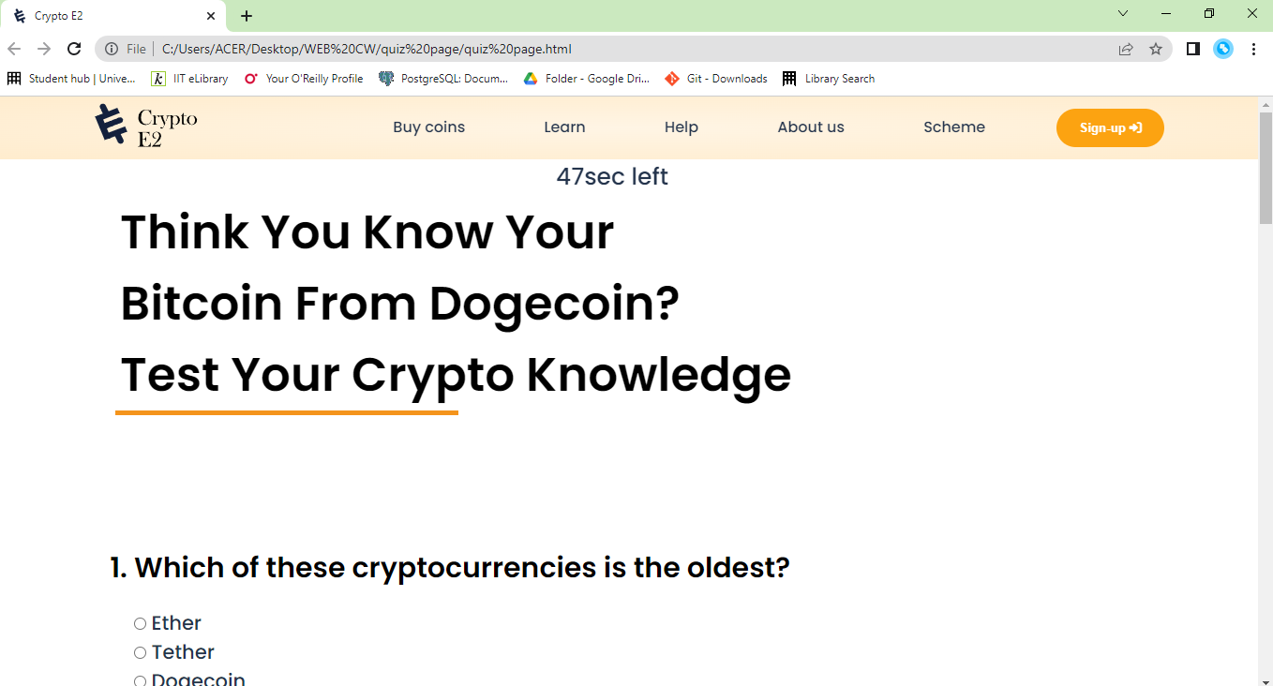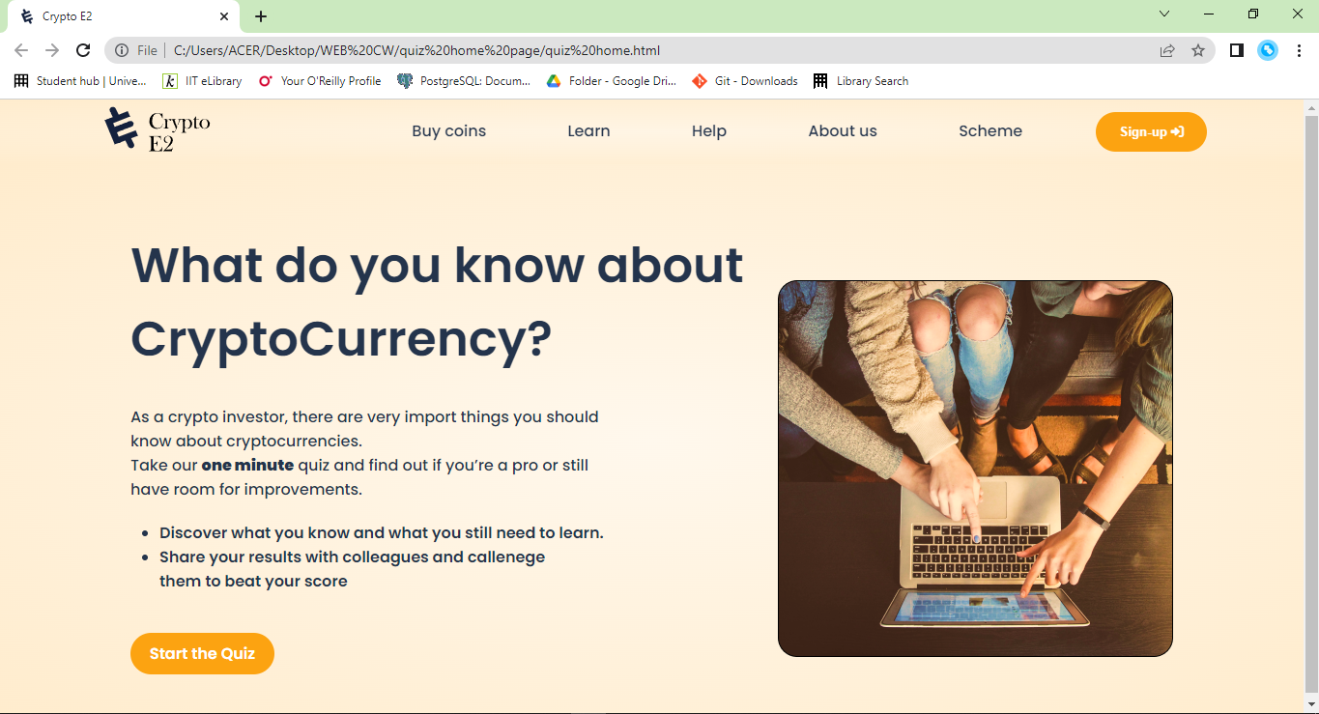

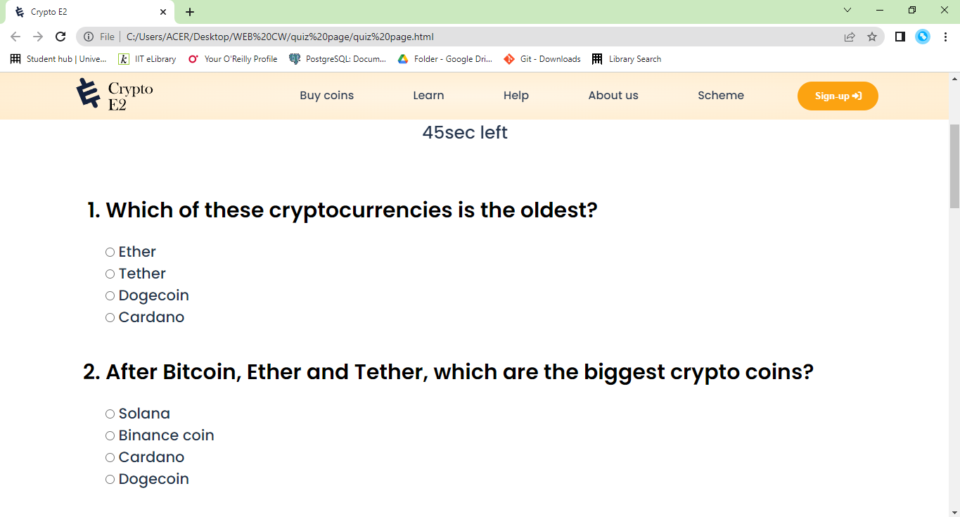

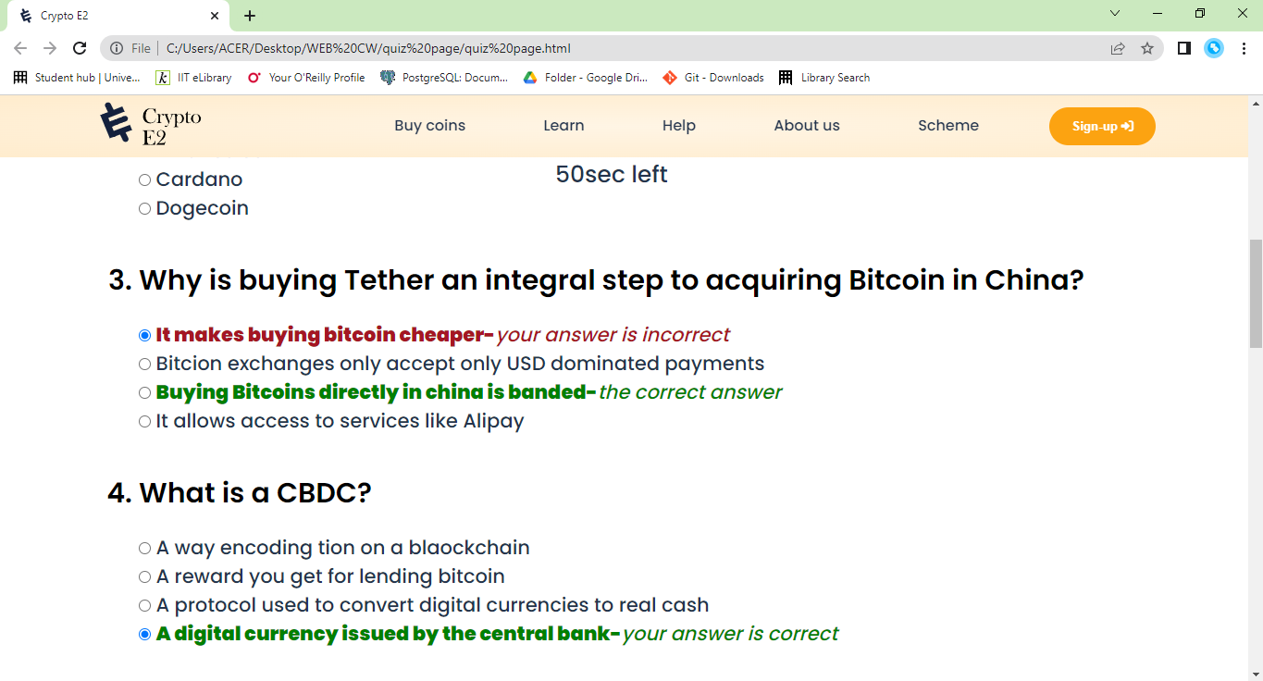

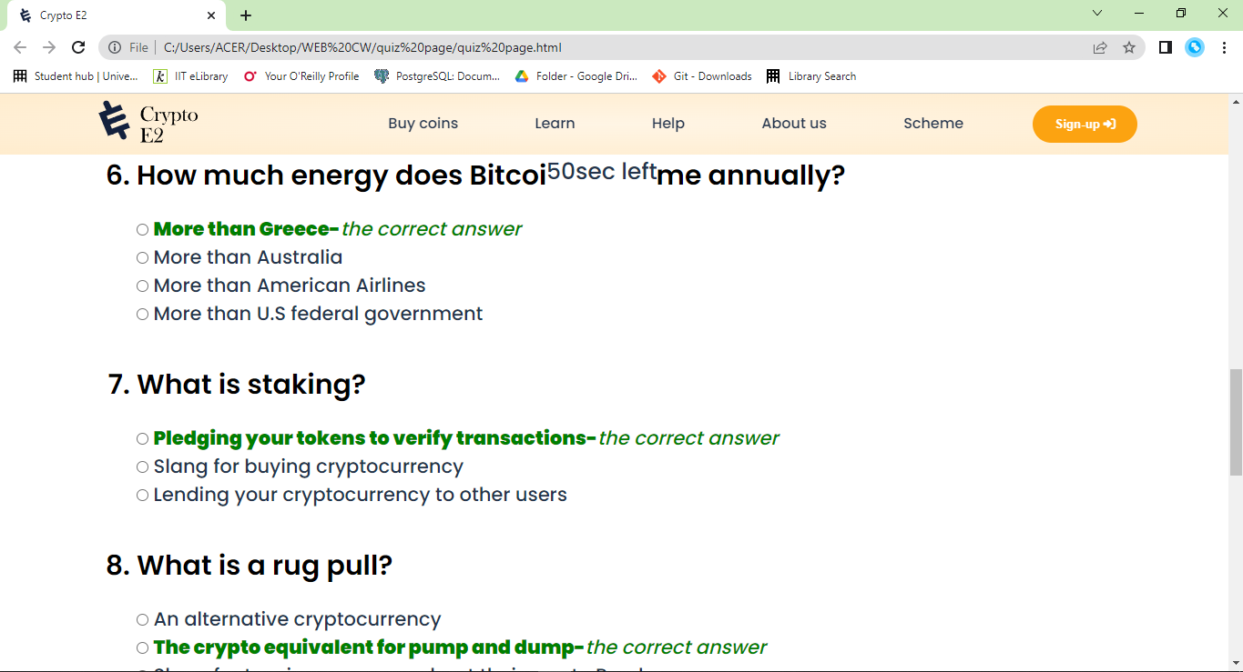

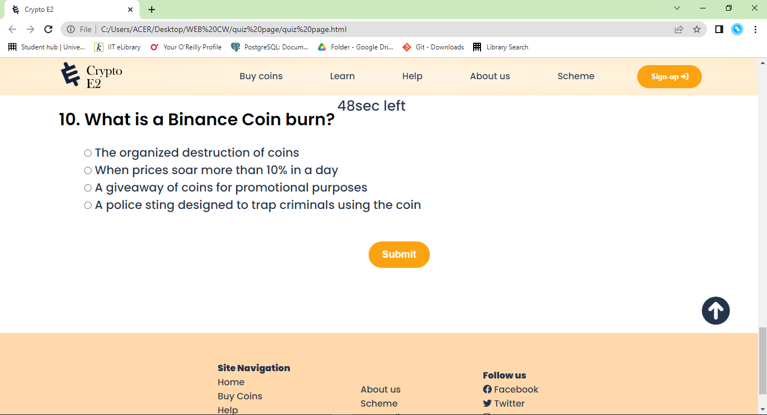

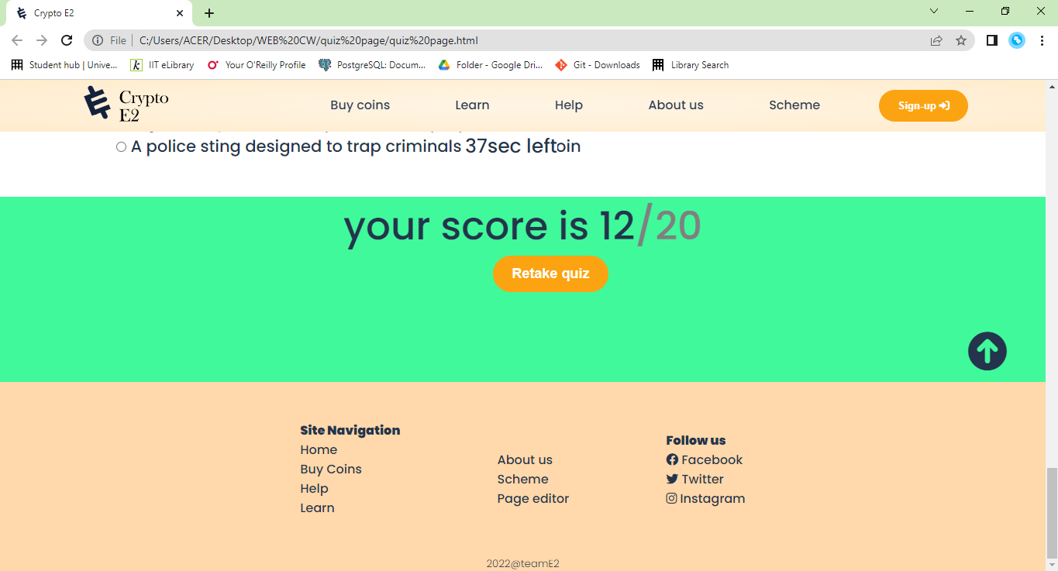

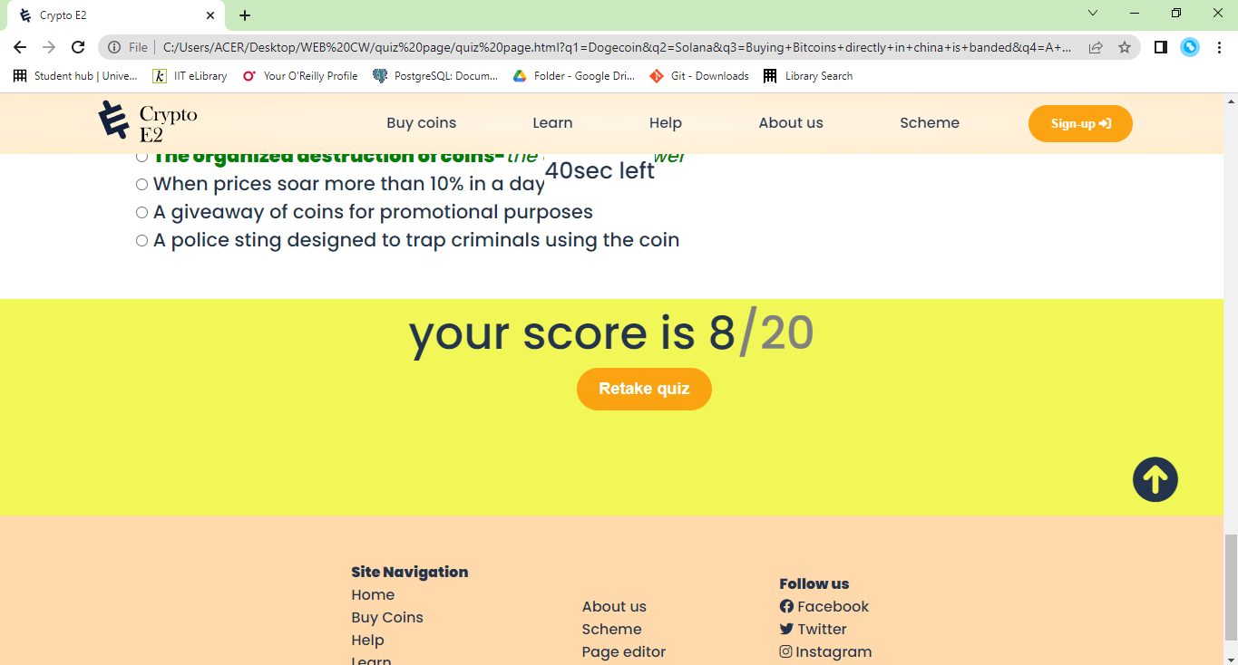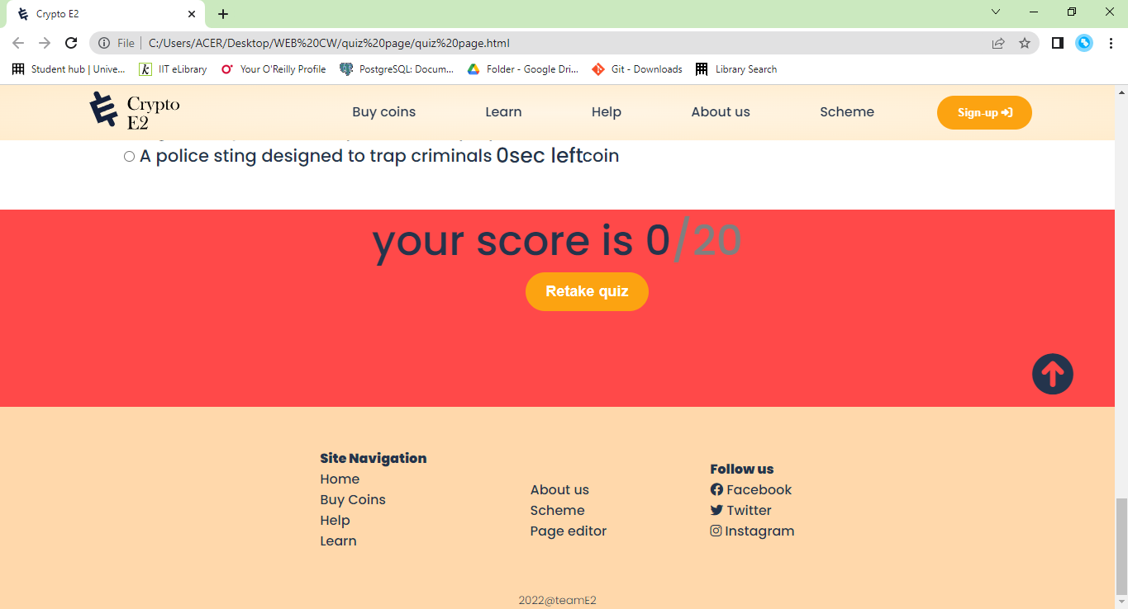

**about us.html**

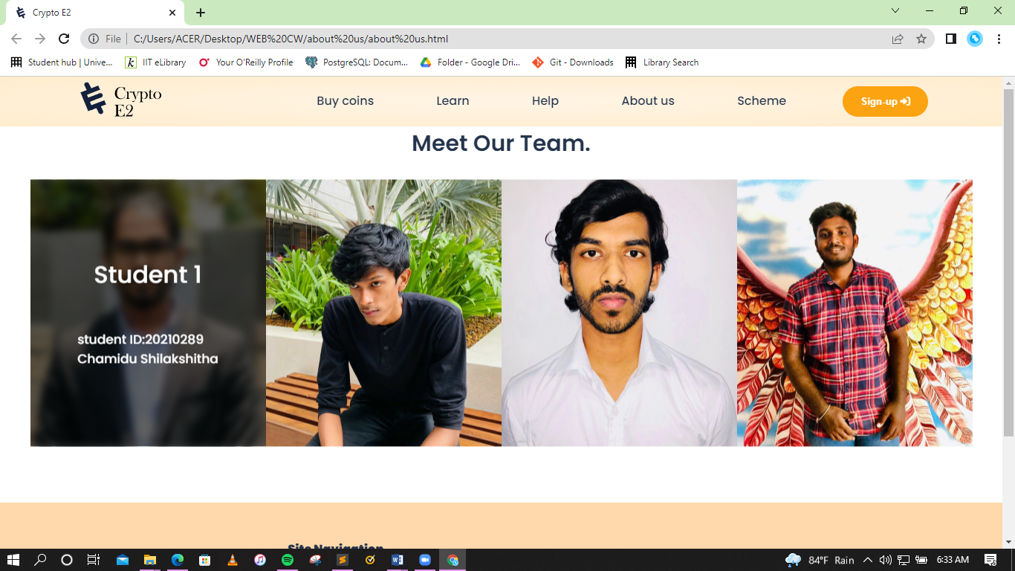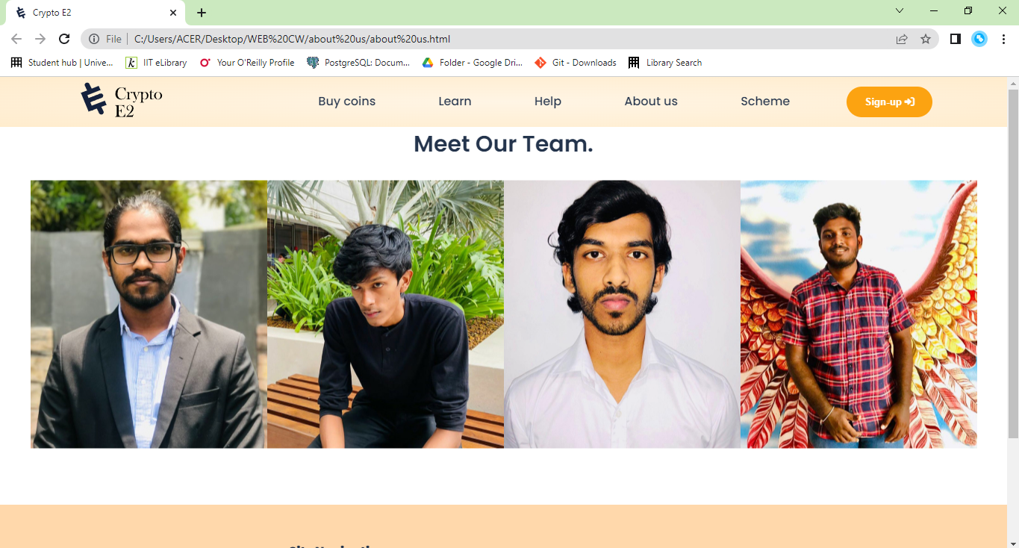

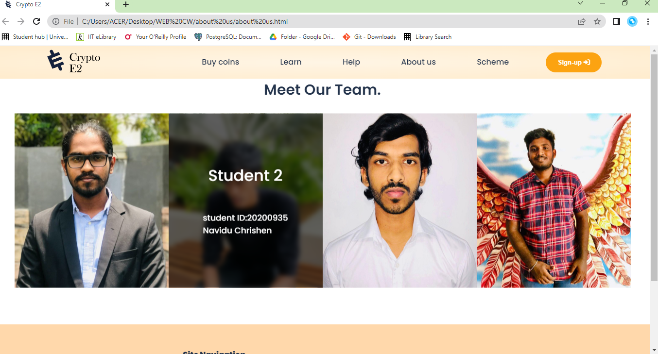

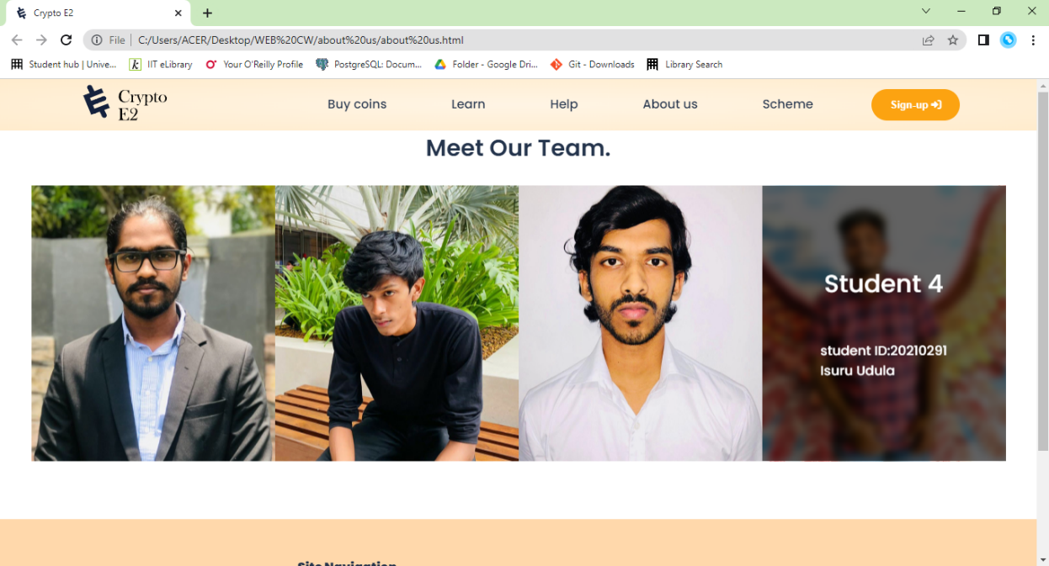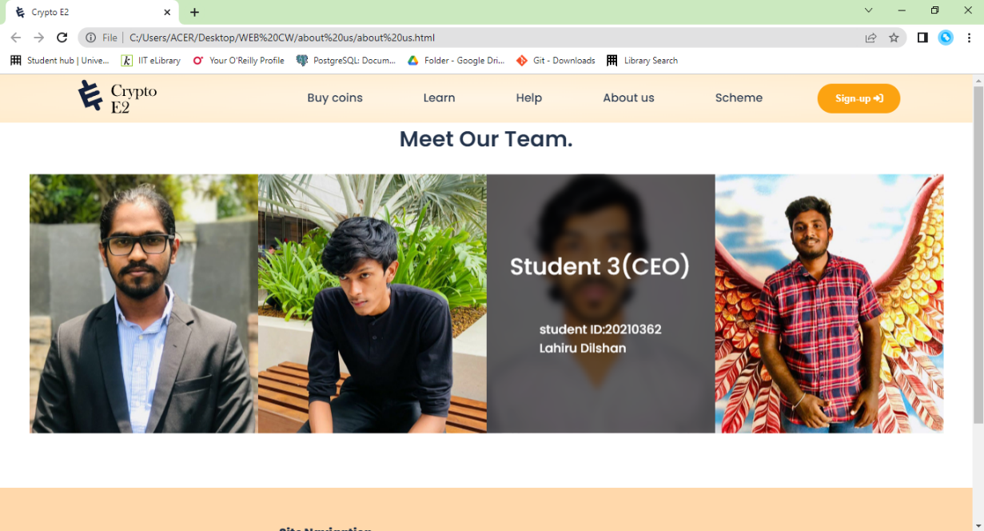

**Page editor**

**(with gradient background color animation)**

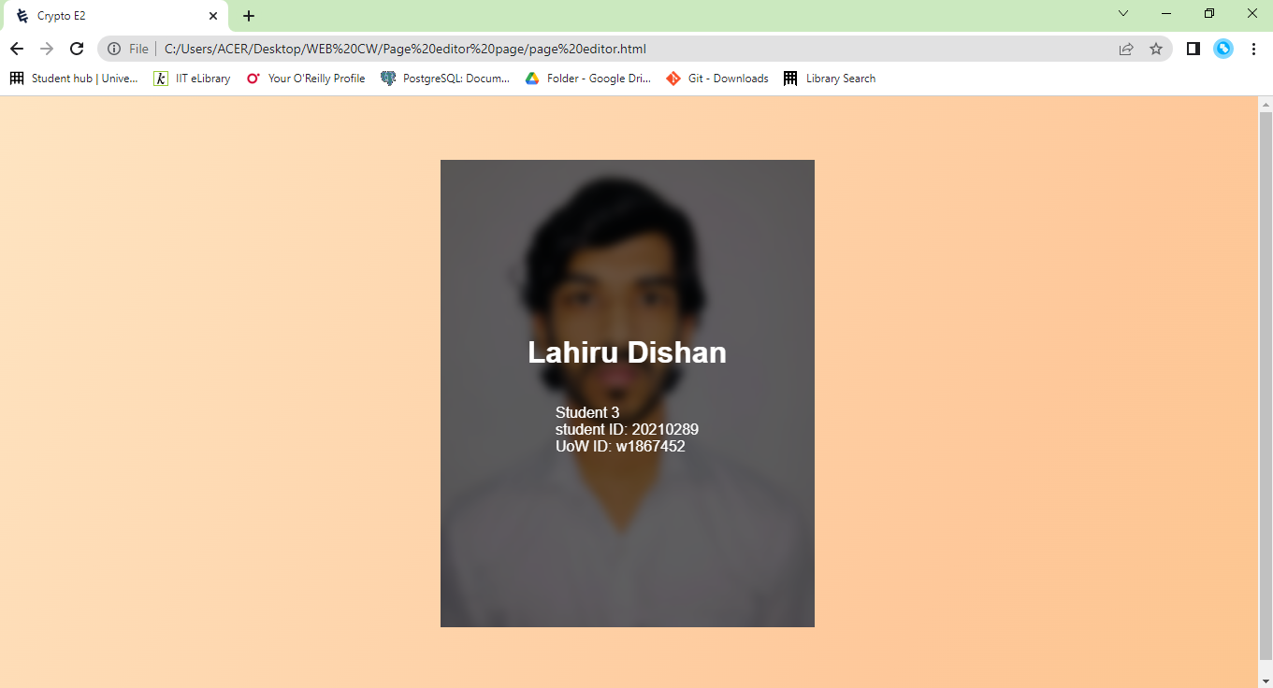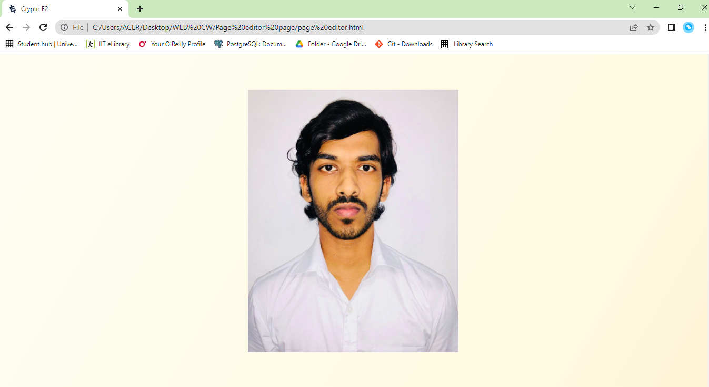

|  |  |  |  |  |  |
| --- | --- | --- | --- | --- | --- |
| **Student Name:** | **U.K.L Dilshan** | | **Student ID:**  **Uow ID:** | | **20210362**  **w1867452** |
| **State what tasks you carried out in the project.** | | | | | |
| * **About Page & Quiz Page (Student – 03)** | | | | | |
| **State what you enjoyed and did not enjoy about teamwork.** | | | | | |
| * **Working together is fantastic because it allows us to hone our soft skills and learn how to function as a group.** | | | | | |
| **State what you learnt about teamwork.** | | | | | |
| * **I learnt to pay attention to everyone's viewpoints and to take conclusions from a growing number of opportunities.** | | | | | |
| **State what skills you gained/learnt from undertaking the project.** | | | | | |
| * **Effective Communication** * **Teamwork** * **Ability to work under pressure** * **Analytical Thinking** * **Project Management** * **Problem Solving** | | | | | |
| **State any strength about yourself that emerged whilst undertaking the project.** | | | | | |
| * **I was able to increase my HTML, CSS, and JavaScript coding skills.** | | | | | |
| **State any weaknesses about yourself that emerged whilst undertaking the project.** | | | | | |
| * **I couldn't figure out how to put the time system into JavaScript but finally found a way to achieve the task.** | | | | | |
| **State how you would do things better if you were to undertake the project again.** | | | | | |
| * **I'll devote additional resources to the process and look for innovative methods to implement it.** | | | | | |
| **Additional general or project specific comments:** | | | | | |
| * **This is a fantastic project, and I learnt a lot about web page principles as a result.** | | | | | |
| **Student Signature:** | | **lahiru** | | **Date:** | **March 31, 2022** |

Thank you